Implementing DACS in Integrated Content Management Systems:
Using the Archivists' Toolkit™ (AT)

A Workshop Presented by
The Society of American Archivists

26 & 27 September 2011

Washington, D.C.

Instructors:

Bradley Westbrook
UC San Diego Libraries
(bdwestbrook@ucsd.edu)
Rachel Onuf
Consultant
(rachel.onuf@simmons.edu)

Organization of this Workbook

Schedule at a glance | 3
Learning objectives and Caveat Emptor | 4
I. DACS overview | 6
II. Archivists' Toolkit overview | 11
III. Repository records | 15
Exercise 1 | 18
IV User records | 19
Exercise 2 | 21
V. Location records | 22
Exercise 3 | 26
VI. Accession records | 27
Exercise 4 | 34
VII. Resource descriptions | 35
Exercise 5 | 49
VIII. Resource Components, Instances, and the Rapid Data Entry Tool | 50
Exercise 6 | 59
IX. Subject and other controlled vocabulary records | 60
Exercise 7 | 64
X. Name records | 65
Exercise 8 | 76
XI. Linking description parts | 77
Exercise 9 | 86
XII. Importing | 87
Exercise 10 | 94
XIII. Data Cleanup | 95
Exercise 11 | 104
XIV. Generating reports | 105
Exercise 12 | 111
XV. Exporting EAD, MARCXML, and print finding aids | 112
Exercise 13 | 121
XVI. Putting it all together Exercise 14 (Final exercise) | 122
Appendix A: Getting started with the Archivists' Toolkit | 123

Credits

The following persons have contributed to the construction of this workbook and its modifications since the first SAA-sponsored workshop in March 2008: Arwen Hutt, William E. Landis, Rachel Onuf, Sybil Schaefer, Kelcy Shepherd and Bradley D. Westbrook

Schedule at a Glance

Day One

9:00 am | Introductions – Overview – DACS overview – AT overview
10:00 am | Repository records – Exercise 1
10:15 am | User records – Exercise 2
10:30 am | Location records – Exercise 3
10:45 am | BREAK (15 minutes)
11:00 am | Accession records – Exercise 4
12:00 pm | LUNCH (1 hour)
1:00 pm | Resource descriptions (Single level records) Exercise 5
2:00 | BREAK (15 minutes)
2:15 pm | Resource descriptions (Multilevel records, Instances, and the Rapid Data Entry Tool – Exercise 6
4:15 pm | First day wrap up

Day Two

9:00 am | Questions from first day – Overview of second day
9:15 am | Subject and other controlled vocabulary records -- Exercise 7
9:45 am | Name (corporate, personal, family) records – Exercise 8
10:30 am | BREAK (15 minutes)
10:45 am | Linking description parts – Exercise 9
11:15 am | Importing legacy data – Exercise 10
12:30 p.m. | Lunch
11:45 am | Data cleanup – Exercise 11
1:30 pm | Generating reports – Exercise 12
2:00 pm | Exporting EAD, MARCXML, and print finding aids – Exercise 13
2:30 pm | Bringing it all together – Exercise 14 (final exercise)
 | Participants can take breaks anytime between 2:30 and 4
4:00 pm | Exercise review
4:15 pm | Follow up questions and workshop evaluation
Learning Objectives
Upon completing this workshop, you’ll have learned how to use the Archivists’ Toolkit to:
- Create accession descriptions
- Create resource descriptions for collections and collection components
- Create and manage name and subject authorities and link them to accession and resource descriptions
- Record and manage physical locations within a repository
- Produce description output files in standardized data structures such as EAD and MARCXML
- Produce administrative reports
- Import legacy data and perform data cleanup tasks

You will also become more familiar with:
- DACS and how to use it, where applicable, to determine the kind and form of data recorded in the AT
- Technical and administrative issues relevant to setting up and managing an AT instance at your repository

Caveat Emptor

This workshop will not cover the following aspects of the AT:
- Installation, Upgrading and Repairing
- Working with MySQL
- AT Functional Areas and Processes
  - Digital object records
  - Searching
  - Name contact information / contact logs
  - Encoding inline tags
  - Multi-part notes
  - Assessment records
  - Merge/Transfer
- Mapping Legacy Data
- Serving AT exports to the outside world
- Customizing the AT application
- AT/Archon Integration

If time permits, we may touch lightly on some the topics listed above as not being within the scope of the workshop.

You find more information about these topics, and those topics comprising the workshop, in the AT User Manual and New Feature Documents:

User Manuals:
This user manual covers all the functionality of the AT1.1.8, from basic data entry to customization.
http://archiviststoolkit.org/support/userManual1_1

User manual for AT1.5/1.5.9 (for AT 2.0 consult this manual plus new features documentation listed below):
http://archiviststoolkit.org/sites/default/files/AT1_5_UserManual.pdf

New Features documentation for AT versions 1.5, 1.5.9, and 2.0:
http://archiviststoolkit.org/support/newfeatures1_5
http://archiviststoolkit.org/support/newfeatures1_5_9
http://archiviststoolkit.org/support/newfeatures2_0

I. Overview of DACS

DACS is:
- A data content standard for use by archivists in the U.S. to implement archival control of collection material and to produce consistent descriptive tools for users of those collections.
- Based on and incorporates ISAD(G), the General International Standard Archival Description, 2nd ed.
- Designed to be used, when necessary, with companion standards.
- Output neutral.
- A standard designed to support iterative use throughout the lifecycle of an archival collection.
- A standard that supports both single-level and multilevel archival description.

Let's look a little more closely at each of these.

1a. DACS is a data content standard.
- Data structure: Elements or containers in which descriptive data are stored.
  - <physdesc></physdesc> and <extent></extent> are Elements in the Encoded Archival Description (EAD) data structure.
  - 300 is an Element in the MARC21 data structure.
- Data content: What you put into those elements or containers (in the examples below, 2 linear feet is the data content).
  - <physdesc><extent>2 linear feet</extent></physdesc> (in EAD elements).
  - 300 bb $a 2 $f linear feet (in a MARC21 element).
  - This example of data content, 2 linear feet, is formulated using DACS rules 2.5.3 and 2.5.4.

1b. DACS implements archival control.
- A good definition of ARCHIVAL CONTROL from OCLC’s Bibliographic Formats and Standards:
"… material is described according to archival descriptive rules, focusing on the contextual relationships between items and on their provenance rather than on bibliographic detail. All forms of material can be controlled archivally."
- The upshot of this is:
  - As long as your approach to controlling/describing your stuff is essentially archival in nature, you can base your descriptive practices on DACS and work outward from there.
  - "Archival" is an approach to managing information and NOT an essential characteristic of the material in question.

2. DACS is based on and incorporates ISAD(G).
- ISAD(G) is the general international standard for elements of archival description.
  - "General" = no format-specific chapters, applicable to all.
- Created and published by the International Council of Archives (1994, revised 2000).
- A high-level standard meant to be "used in conjunction with existing national standards or as the basis for the development of national standards."
- ISAD(G) provides:
  - Four rules for multilevel description (paraphrased):
    - Describe from the general to the specific.
    - Include information at the relevant level of description within the hierarchy.
    - Link descriptions at various levels to make explicit the position of each unit within the hierarchy.
    - Avoid redundancy of information by not repeating information at more than one level within the hierarchy.
  - Definitions of twenty-six elements "broadly applicable to descriptions of archives regardless of the nature or extent of the unit of description."
- "The structure and content of the information in each of these elements should be formulated in accordance with applicable national rules." In the U.S., those "applicable national rules" are DACS.

ISAD(G) [26 elements] and DACS [25 elements]: ISAD(G) only / DACS only

- Reference Code
- Name/Location of Repository
- Title
- Date(s)
- Level of Description
- Extent
- Name of Creator(s)
- Admin/Biog History
- Scope and Content
- System of Arrangement
- Conditions Governing Access
- Physical/Technical Access (2 separate elements in DACS)
- Conditions Governing Reproduction
- Languages/Scripts of Material
- Finding Aids
- Archival History -- Custodial History
- Immediate Source of Acquisition
- Appraisal/Destruction/Scheduling
- Accruals
- Existence/Location of Originals
- Existence/Location of Copies
- Related Archival Materials
- Publication Note
- Note(s)
- Archivist’s Note / (2) Rules or Conventions / (3) Date(s) of Description -- Description Control

3. DACS is designed to be used, when necessary, with companion standards.
- Companion standards are any additional standards that you need to use in conjunction with DACS to describe the materials in your repository.
- Data content standards, for example:
  - Graphic Materials or Cataloging Cultural Objects (CCO) for describing individual photographs in archival collections.
  - Descriptive Cataloguing of Rare Materials (Books) (DCRM(B)) for describing rare books in archival collections.
  - The IASA Cataloguing Rules: A Manual for the Description of Sound Recordings and Related Audiovisual Media for describing individual audio recordings in archival collections.
- Data value standards, for example:
  - Art and Architecture Thesaurus for genre terms used in DACS Extent (2.5) and Scope and Content (3.2) elements
- Ways of utilizing companion standards with DACS:
  - Use in place of or to enhance DACS rules for specific elements when you need detailed item-level guidance that DACS doesn't provide.
    - For example, rules for the Extent element from The IASA Cataloguing Rules provide much more detail for item-level descriptions of sound recordings than the Extent element rules in DACS do. If that matters in your repository, you can use them in addition to or instead of the DACS Extent Element (2.5) rules
  - Use elements and rules in companion standards that do not appear in DACS when these are useful.
    - For example, CCO provides elements (and rules for their content) for Style and Culture, two elements that are beyond the scope of DACS. These elements might be useful, in addition to the 25 elements defined by DACS, at the series- or item-levels to archivists describing cultural object components in an archival collection, or the records of an archaeologist or a museum.
  - At granular levels of description, use a companion standard completely instead of using DACS if your repository and users require more detailed descriptions than the elements and rules in DACS can provide.
    - For example, use DACS for collection-, series-, and file-level descriptions for the bulk of your archival materials, but use Graphic Materials to describe the individual items in a photographs series.
- In all cases, DACS encourages you to (the Mantra):
  - Take a well thought out, consistent approach that incorporates the goals and resources of your repository, the kinds of collections you have, and the needs and expectations of your primary user constituencies (apply professional judgment).
  - Document your decisions about local application of standards.

4. DACS is output neutral.
- Focus is on data reuse – input once, output many.
- Data content formulated according to DACS rules can be output to many data structures, for example:
  - An EAD file.
  - A MARC21 record.
  - A print finding aid.
  - A MODS or DC record in a METS-encoded digital object.
- Output neutrality is critical for flexible 21st century data content standards!

5. DACS is an iterative standard.
- It is designed to be used by U.S. archivists to capture and formulate descriptive information about groupings of archival materials in their current state of arrangement (or lack thereof).
  - The information content for DACS elements can and will change as archival materials move through the stages within your repository (e.g., acquiring, processing, use).

6. DACS is designed to produce both single- and multilevel descriptions.
- Single-level Description can describe archival material at any level (collection, series, item), but only at that level, for example:
  - A collection-level MARC21 record
- Multilevel Description can describe archival material starting at any level, but must include at least one sublevel, for example:
  - A finding aid that includes collection, series, and file descriptions.
- DACS provides recommendations in Chapter 1 for Minimum, Optimum, and Added Value use of DACS elements.

II. Overview of the Archivists’ Toolkit

The Archivists’ Toolkit is:
- Designed as an open source, relational database application to support basic collection management, archival processing, and production of access instruments.
- An application that promotes data standardization.
  - Based on DACS, ISAAR (CPF).
  - Exports EAD, MARCXML, METS, MODS, DC.
- An application that promotes efficiency.
  - Integrates a range of archival functions.
  - Facilitates repurposing of data.
  - Automates encoding and reporting.
- An application that lowers local staff training costs.

NOTE: All screenshots in this workbook are of the Archivists’ Toolkit application running on Ubuntu 10.10 operating system. The AT will appear slightly different when running it on other operating systems, including earlier versions of Ubuntu.

AT Interface
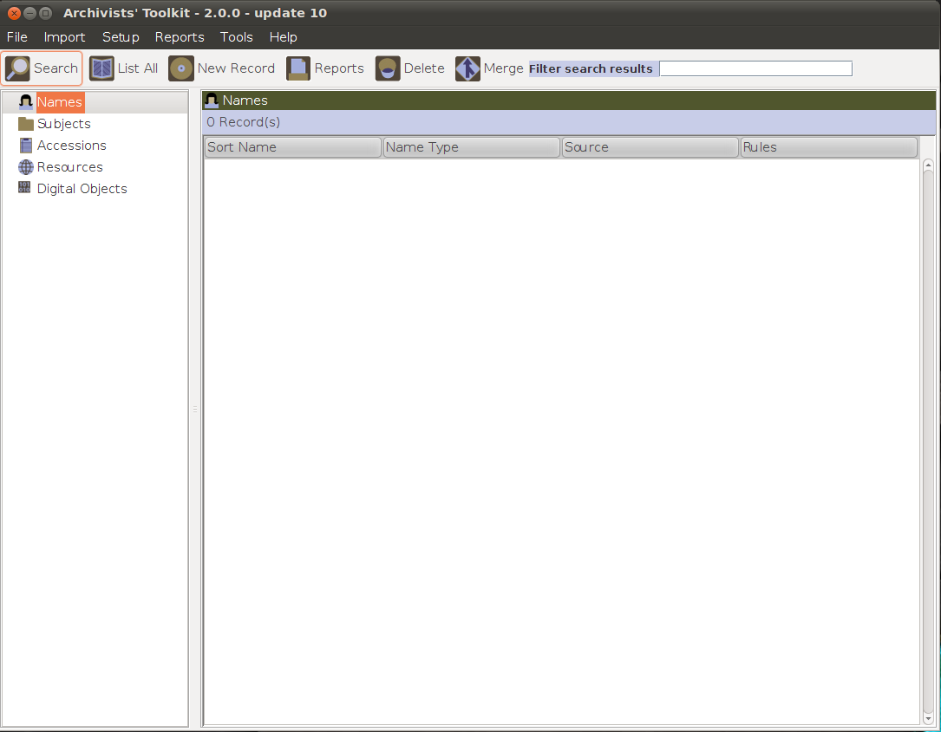
Menu/Command Zone
Navigation Zone

List Screen Display

AT Basic Record Parts

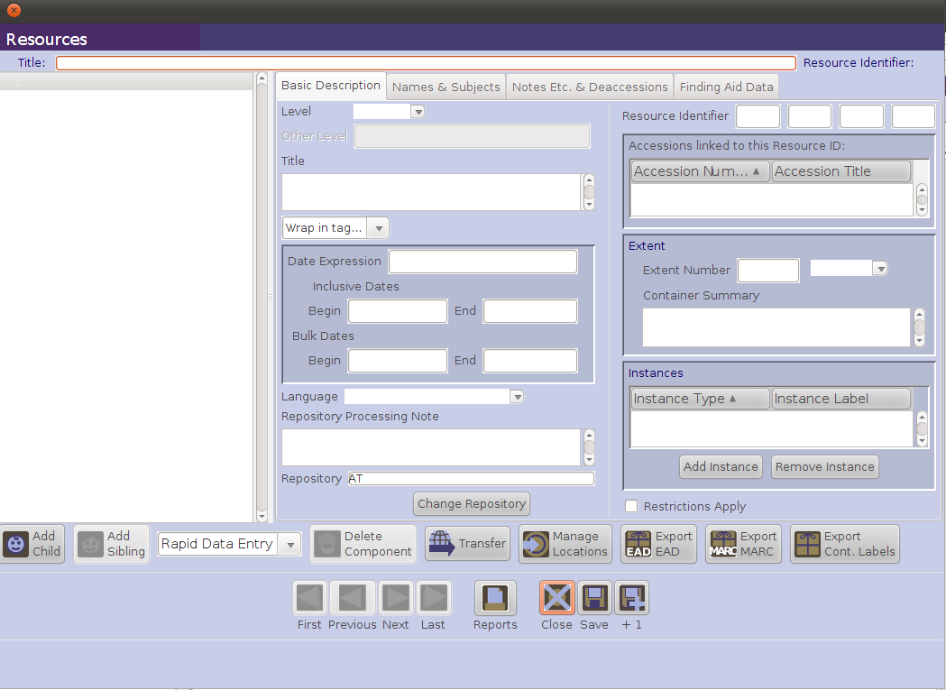
Component Buttons
Data Entry Window
Navigation Buttons
Command Buttons
Title Bar
Component List

AT Rollovers

Rollover texts are associated with almost all of the labels in the various AT record templates.

Typically, the rollover consists of a definition of the element, a reference to the appropriate rule in DACS or to elements in export data formats such as MARC, and examples of local practice.

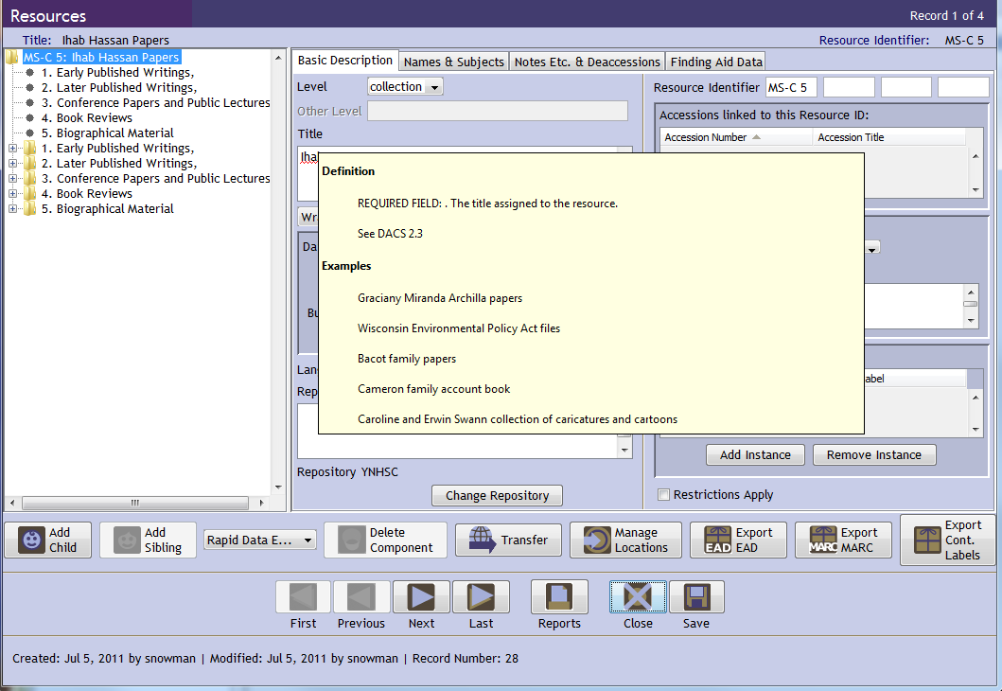

The rollover texts can be completely modified, with the understanding that the resultant modifications are for all users and thus in a multi-repository installation, cannot be constrained only to the users of one repository versus another. The rollover feature provides a repository the means to integrate its processing procedures directly into the application.

AT Primary Record Types

The AT has numerous database records. Many are sub-records to primary records, such as deaccession records, and serve to record information for a sub-process such as recording container information for instances. The primary records are:

- Repository record
For identifying the repository having custody of the resources described. Includes sub-records for expressing data defaults to be used by the repository and basic characteristics of the physical repository, as well as its holdings and staff.

- User record
For creating and managing Toolkit user accounts.

- Location record
For indicating the location(s) at which a resource is or may in the future be located. Location records may be defined in advance and then linked to a resource as it is processed and then shelved at the location.

- Accession record
For recording accessions and basic collection management data.

- Resource record
For describing an item or collection of items in a standard multilevel manner. The resource record contains sub-records (RCr) for resource components, digital objects, and material instances (e.g., text, microform, tape). A sub-record is a linked record that can only be viewed, created, and edited through the primary record.

- Subject record
For describing topical terms associated with an accession or a resource. The subject records serve as subject headings in exports such as EAD, MARCXML, and MODS.

- Name record
For recording the names (personal, corporate body, or family) associated with an accession or a resource as a creator, source, or subject. The name records serve as name headings in exports such as EAD, MARCXML, and MODS.

- Assessment record
For quantitatively and qualitatively surveying accessions, resources, and digital objects in order to prioritize work.

- Digital Object record
For describing a digital object that is either digitized or born digital. The digital object can be described at a single level or multi-level. The digital object record supports component level records and sub-records for file versions. The digital object record can be created from within a resource record, or created independently and then either linked or not to a resource record.
III. Repository records

Function of repository records within the Archivists' Toolkit:

A repository record is created during the initial set up of the Toolkit. After set up, this record can be edited and additional repository records can be created. The repository record serves two basic purposes: to store information for later output and to differentiate between repositories.

The repository record stores data like the repository’s contact information and identifying codes for later output in EAD and METS headers and administrative reports. Recording and storing this information in one place – at the repository level of description – alleviates the need for repetitive data entry at the resource level and makes revision of all AT exports easier.

The second purpose of the repository record is to distinguish one repository’s accession records, resource records, and data rules from those of another repository using the same AT implementation in a multi-repository implementation of the Toolkit.

Application of DACS to repository records:

Rules in the following DACS elements provide assistance for formatting data for parts of the AT Repository Record.

2.1 Reference Code Element | - The rules for the Repository Identifier (2.1.4) should be consulted for the creation of the Agency Code in the AT and the rules for the Country Identifier (2.1.5) should be used to determine the Country Code.
2.2 Name and Location of Repository Element | - These rules should be followed when filling in the fields related to the name and location of the repository.

Creating repository records in the Archivists' Toolkit:

When creating a repository record, only two data fields are required:
- Repository.
- Short Name.

Steps in creating a repository record:

- From the Setup menu, select Repositories.
- Press the Add Record button.
- Enter the Repository Name. This is the official name that will appear on administrative reports and descriptive outputs.
- Enter the Short Name for the repository, which will appear in the Toolkit interface.

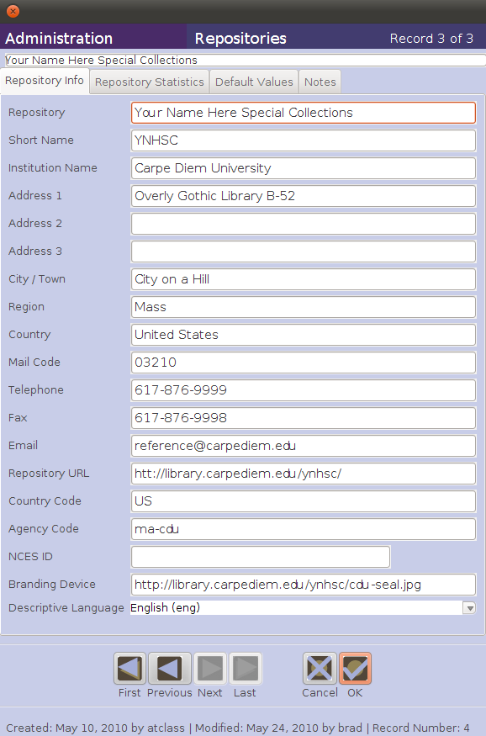

- Enter detailed contact information, the Branding Device (the URI for the repository logo), and the primary Language used for description by the repository, as desired.
- Save the repository record by pressing the OK button at the bottom right corner of the window. If you are entering multiple repository records, the OK+1 button will save the record you are working in and open a new repository record.

There are also additional tabs in the repository record for Repository Statistics, Default Values, and Notes, which are described in Chapter 5 of the AT User Manual.
Exercise 1: Repository Records

Create a repository record for the Your Name Here Special Collections by following the directions on pages 16-17 for Creating repository records in the Archivists' Toolkit and using the information provided in the screen shot.
IV. User records

Function of user records within the Archivists' Toolkit:

Once the repository record is completed, the Toolkit is ready to be used by anyone with access to the computers / servers on which the application is installed. It is likely that most repositories using the Toolkit will want to control certain users' access to some of the information or features of the application.

The Toolkit provides the means to assign a user to one of five access classes. The classes represent an expanding sequence of functionality and access. Class 5, for instance, represents access to all the functionality and information stored in the AT for all repositories, and thus has “superuser” permissions. As with other systems, it is not recommended to do daily work in the Toolkit while logged in as a superuser. Therefore, the Toolkit’s administrator may wish to create and use two accounts -- one as the superuser and one with Class 4 permissions, which is what we will do in the upcoming exercise. Class 1, the default value, represents access to very basic data entry functions for describing already accessioned resources and their components. See the “User Permissions Table” in the AT User Manual Appendices for more information about the various access classes.

Application of DACS to user records:

There are no rules in DACS applicable to the creation of user records in the Archivists' Toolkit.

Creating user records in the Archivists' Toolkit:

When creating a user record, only two elements are required:
- Username.
- Password.

Steps in creating User records:

- From the Setup menu, select Users.
- Press the Add Record button.

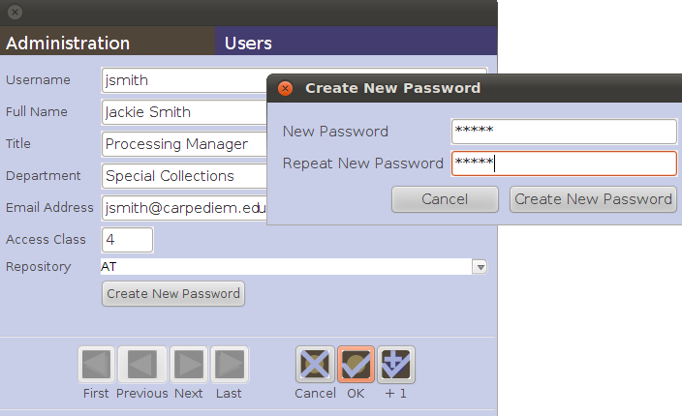

- Enter a Username.
- Enter the Full name, Title, Department, Email, Access Class, and Repository for the user.
- Press the Create New Password button to assign a password.
- A window will appear asking you for the New Password. Enter a password, re-enter it in the Repeat New Password box, and press the Create New Password button.
- Save the user record by pressing the OK button at the bottom right corner of the window. If you are entering multiple user records, the OK+1 button will save the record you are working in and open a new repository record.

Exercise 2: User Records

Create a new user record for yourself, following the directions on pages 19-20 for Creating user records in the Archivists' Toolkit. Give yourself an Access Class of 4 and select Your Name Here Special Collections as your Repository.

BE SURE TO WRITE YOUR NEW USERNAME AND PASSWORD IN THE FRONT OF YOUR WORKBOOK SO THAT YOU DON'T FORGET IT. Consider creating a simple pair such as your first name for the usersname (brad) and your first name reversed for the password (darb).

Since you are still logged in as a Class 5 “superuser,” close out of the AT and log on again, using your new class 4 username and password. Use this class 4 username for the duration of the workshop, unless instructed otherwise.
V. Location records

Function of location records within the Archivists' Toolkit:

Location records assist in keeping track of where accessions and resources are physically located within a repository.

Location records are for describing where materials are stored. They use a coordinate system to represent a repository’s shelving space. For example, a coordinate may be a range, shelf, or flat file storage number. Up to three of these coordinates can be recorded. If storage units have not yet been assigned some sort of unique identifier, they will need to be named in some manner in order to create location records in the AT. Location records can be input and edited at any time, but it may be most effective to create them one time for an entire repository and link to them as needed.

Application of DACS to location records:

There are no rules in DACS applicable to the creation of location records in the Archivists' Toolkit.

Creating location records in the Archivists' Toolkit:

Location records can be created one at a time before or at the time of accession or resource description. As a time saving device, location records can also be created in batches as part of the AT set up (in effect pre-populating your database), or as new storage units are established. Those location records can then be assigned to accessions and resources as needed.

Steps in creating Location records

- From the Tools menu, select Locations.
- Click on Add Record to add a single location record or Batch Add to generate a batch of location records.
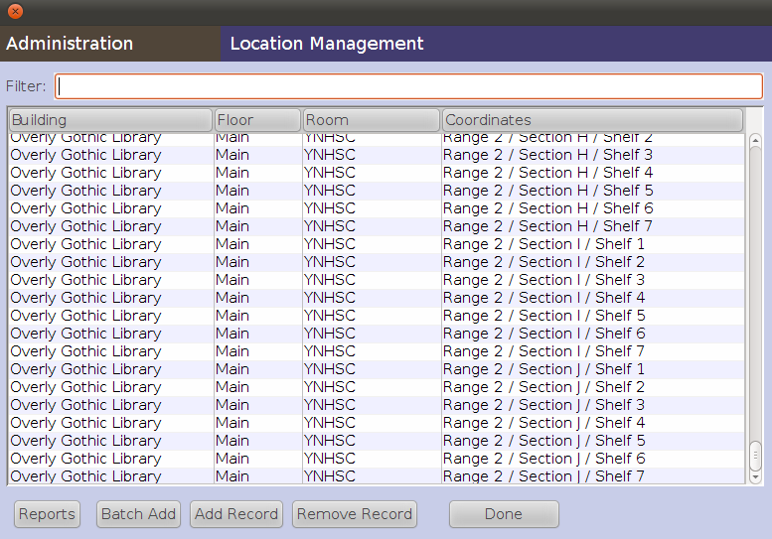
2

Creating single location records:

- When creating a single location record, record a value for Building name and Coordinate 1 or, instead, record a value for either Barcode or Classification Number. This is the minimum amount of data that the AT requires for a single location record.
- Save the location record by pressing the OK command button at the bottom right corner of the window to return to the Location Management screen. If entering more than one single location record, click on the +1 button. This will save the current record and open a new location record template.

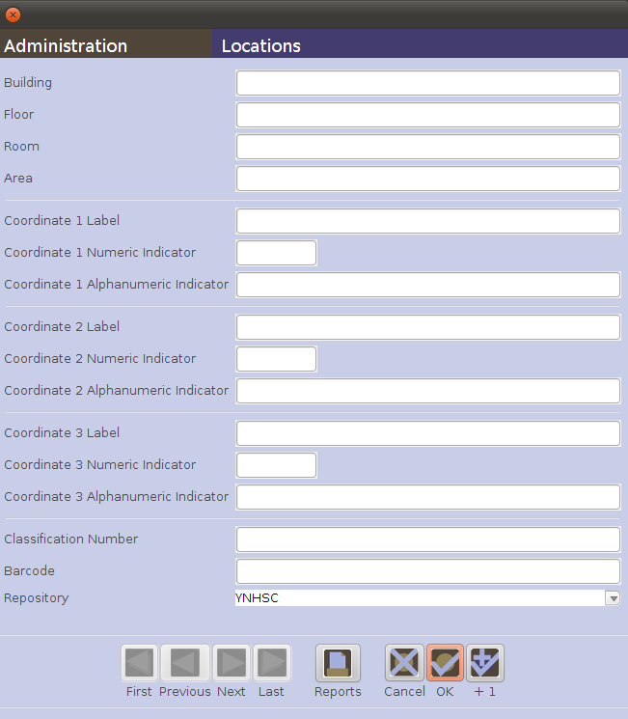
3
3
4
3
3

Creating batches of location records:

- When creating a batch of location records, record a value for the Building name and a value for Coordinate 1. These are the minimum data values required to generate a batch of location records.
- Click on the Generate button to generate one or more records (the number of records generated is determined by the coordinate information provided).

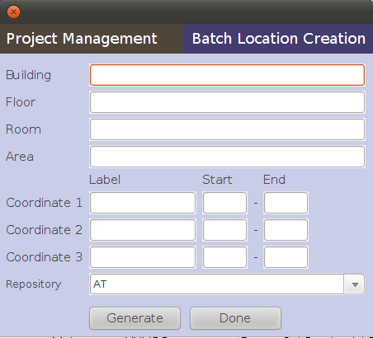
5
5
5
5
8
6

- Generate additional batches of records by changing values for the coordinates or, if appropriate, values for the shelving location.
- Click on the Done button to quit the batch add process and return to the Location Management screen.

The following additional data elements are available for both batch and single records, allowing the user to be quite granular in assigning locations:
- Floor
- Room
- Area
- Coordinate 2
- Coordinate 3

Exercise 3: Location Records

Follow the directions on pages 22-25 under Creating location records in the Archivists' Toolkit.

Carpe Diem University Library Special Collections department has set aside specific parts of its stack area for shelving archival materials. This area consists of one double-sided range, composed of ten sections, with seven shelves per section. In addition there are four map cases, each having five drawers, and one lateral file cabinet for holding audiovisual materials, having three drawers.

Create single records for the three drawers in the lateral file cabinet, using the OK+1 feature:

- Lateral File Cabinet A, Drawers 1 through 3.

Create batch records for the following two sets of storage units:

- Ranges 1 through 2, Sections A through J for each Range, Shelves 1 through 7 for each Section.
- Map Cases A through D, Drawers 1 through 5 for each Map Case.

VI. Accession records

Function of Accession Records within the Archivists' Toolkit:

Accessioning is the process of recording the acquisition transaction, in which a repository takes custody of an archival resource.

An accession record in the AT serves the following functions:

- Identifies the accession.
- Records the date of the accession.

Substantially more information can be expressed at the time of the accession. Some of this information promotes understanding of the accession, its contexts and contents, its source, and its relationship to other resources in the repository. In addition, other information about administrative actions, completed or pending, might be added to the accession record. It is important to remember that information in Accession Records in the AT is not included in either MARCXML or EAD exports. There are, however, several ways to use the AT's reports function to generate information from Accession Records.

Application of DACS to Accession Records:

Rules in the following DACS elements provide assistance for formatting data for parts of the AT Accession Record.

2.3 Title Element | - All of the DACS Title Element rules are useful in formulating information about a Title for an accession on the AT Basic Information tab, especially when an accession represents a new collection for the repository. Of course, a title created during the accessioning process may change as a collection is examined in more detail during processing.
2.4 Date Element | - All of the DACS Date Element rules are useful in formulating dates for the elements on the AT Basic Information tab: Date Expression, Date Begin and End, and Bulk Dates Begin and End.
2.5 Extent Element | - All of the DACS Extent Element rules are useful in formulating meaningful, uniform extent statements (Extent Number, Extent Type, and Container Summary) for accessions on the AT Basic Information tab. As in all applications of DACS rules, the repository should adopt a consistent approach to recording accession extents in the AT, and document that local practice.
3.1 Scope and Content Element | - All of the DACS Scope and Content Element rules provide useful guidance for the kinds of information about an accession that should be included in the Description field on the AT Accession Notes tab.
Creating basic Accession Records in the Archivists' Toolkit:

The following data fields are required when creating a new accession record in the AT:

- Accession Number is a data element that provides a unique number associated with each accession of a resource. No formula for accession numbers is required by the AT, but typically these are comprised of the four-digit year of accession, followed by a sequential number indicating where the specific accession falls amidst all repository accessions for that year.
- Accession Date.

Steps in creating Accession records:

- From the Main Screen, select Accessions and click on the New Record button.
- Enter a unique Accession Number (the number may be parsed out over the four sub-fields provided in the AT accession record or recorded completely in the first field if the number is 10 characters or less in length). Uniqueness of the Accession Number is evaluated against all other accession numbers recorded by the repository in the AT.
- Enter the date of the accession in the Accession Date, using the default date format.
- Save the record by clicking on Save.
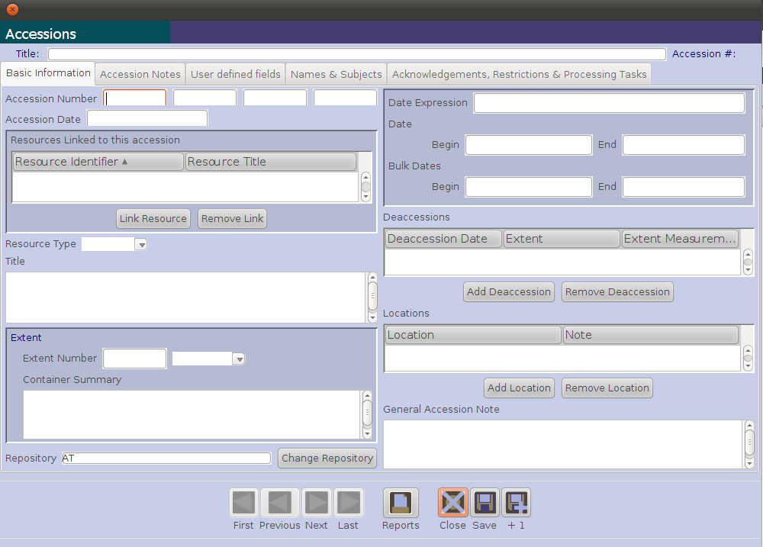
2
3
4

A validation error will result if either the Accession Number or Accession Date fields are not completed.

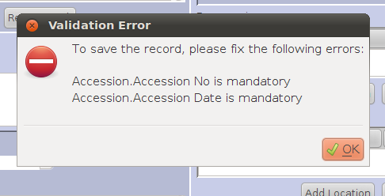
Augmenting Accession Records in the Archivists' Toolkit:

In addition to basic details documenting the accession transaction, substantially more information can be recorded in the accession record about the accession.

On the Basic Information tab, information about the basic characteristics of the accession can be recorded, such as:

- Resources Linked to this accession
- Resource Type (customizable pick list)
- Title
- Extent Number
- Extent Type (customizable pick list)
- Container Summary
- Date Expression
- Date Begin and Date End
- Bulk Dates Begin and End
- Deaccessions
- Locations
- General Accession Note

1
2
3
4
5
6
7
8
9
10
11
12

On the Accession Notes tab, information providing a more detailed description of the accession can be recorded, such as:

- Acquisition Type (customizable pick list)
- Retention Rule
- Description
- Condition
- Inventory
- Disposition Note
- External Documents

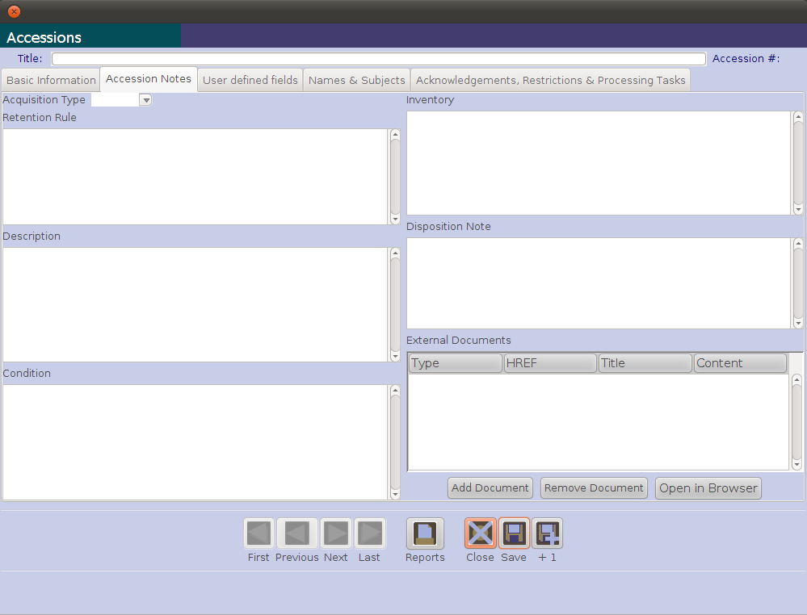
1
2
3
4
5
6
7

On the User Defined Fields tab, there are fields that can be defined by the user for local purposes. User defined fields are one of the customization features present in the AT. Their usage will not be addressed in the workshop. However, information about how they can be defined and used is in Chapter 15 of the AT User Manual.

  - 2 User defined date fields
  - 2 User defined Boolean fields
  - 2 User defined integer fields
  - 2 User defined real number fields
  - 3 User defined string fields (max. length is 255K)
  - 4 User defined text fields (unlimited length)

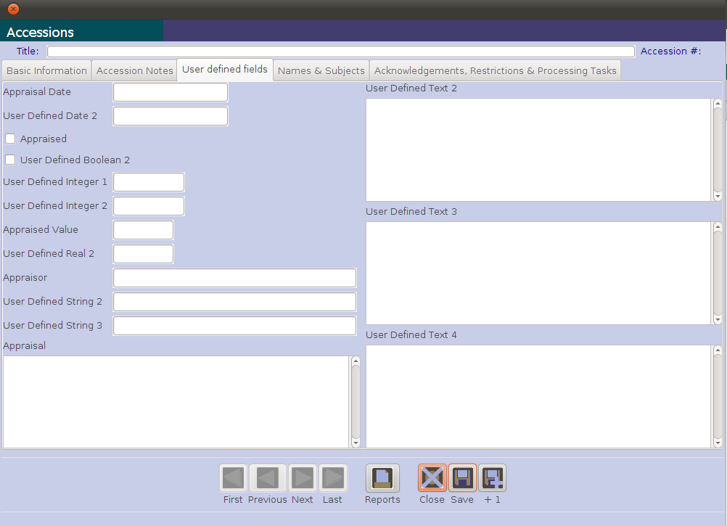

On the Names & Subjects tab (these will be covered later in the workshop) there are data fields for recording the following:
- Names linked to the accession denoting the role of creator, source, or subject
- Subjects linked to the accession denoting content and context information

On the Acknowledgments, Restrictions & Processing Tasks tab there are data fields for recording information about actions, done or pending, relating to accessions, such as:

- Acknowledgement Sent
- Acknowledgement Date
- Agreement Sent
- Agreement Sent Date
- Agreement Received
- Agreement Received Date
- Rights Transferred
- Rights Transferred Date
- Rights Transferred Note
- Restrictions Apply
- Access Restrictions
- Access Restrictions Note
- Use Restrictions
- Use Restrictions Note
- Processing Priority
- Processors
- Processing Plan
- Processing Started Date
- Processing Status
- Processed
- Processed Date
- Cataloged
- Cataloged Date
- Cataloged Note

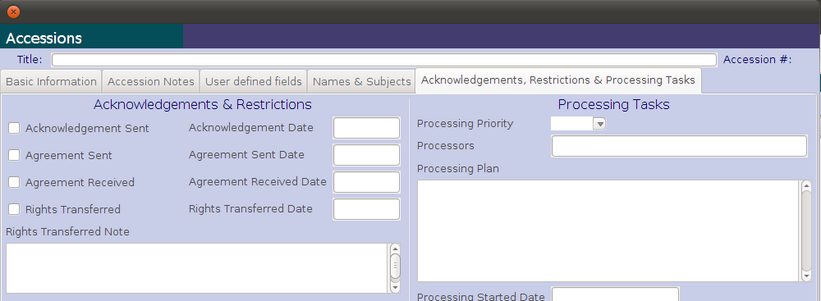

More about creating and using Accession Records in the AT is provided in Chapter 7 of the AT User Manual.
Exercise 4: Accession Records

Use the YNHSC Accession report for Accession number 1986.014, dated 27 March 1986, which is included as “AT-Accession-1-Exercise.doc” in the Workshop Documents folder on the ATvm desktop and as a handout

Create a new Accession record in the AT for this accession. Use as many of the Accession record fields as possible, based on the information given in the YNHSC Accession report.

Make sure you use the AT required fields listed on page 27 of this workbook. Also use as many of the additional fields on the Basic Information tab as you can. Note how they correspond to the beginnings of a Resource Record with the minimum recommended DACS fields (listed on pages 10-11 in DACS).

Indicating the source of the accession will be done later via attachment of a name record. You may, of course, also add a sentence to your accession description indicating its source, if you prefer.

VII. Resource descriptions: single-level records

Function of resource descriptions within the Archivists' Toolkit:

Archival resources in the AT are materials that are in the custody of an archival repository and are being controlled according to archival principles. Each resource has a singular identity, such as a resource (i.e., collection or item) identifier or a title. An archival resource may be comprised of one item, or more typically it will be an aggregation of items that can be of any extent or complexity.

The AT supports description of the archival resource as an intellectual entity and also as one or more physical entities that may embody the intellectual item. The archival resource is managed as being in the custody of a repository and can be described with certain context and content descriptors (names and subjects).

Application of DACS to resource descriptions:

DACS rules are most helpful for the fields in the AT that are available on the Resource Record tabs. Rules in the following DACS elements provide assistance for formatting data for required fields on the Basic Description tab of the AT Resource Record.

2.1 Reference Code Element | - Rule 2.1.3 instructs that your AT Resource Identifier should be unique among the collections in your repository, i.e., you should have a unique collection number for each collection in your repository. DACS does not specify a formula for formatting these reference codes (DACS resource identifiers / AT collection numbers) but gives several examples if you don't have an existing system for formatting them.  - In the AT, the repository identifier (rule 2.1.4) and country identifier (rule 2.1.5), which DACS requires only for exchange of your records outside of your local system(s), are recorded in the AT repository record. The identifiers are then included in the export (EAD or MARC) for each resource description.
2.3 Title Element | - All of the DACS Title Element rules are useful in formulating information about a Title for a Resource Record in the AT.  - DACS rules offer several alternative approaches to constructing some segments of supplied titles (e.g., rules 2.3.19 and 2.3.20 offer different approaches to formulating the nature of the archival unit segment of a supplied title when the unit being described consists of only a few forms of material). You should, therefore, use your professional judgment to decide which specific rules you will apply to different collections or situations in your repository, document those decisions, and then apply them consistently across all of your records in the AT.

2.4 Date Element | - All of the DACS Date Element rules are useful in formulating dates for these elements on the AT Basic Information tab: Date Expression, Date Begin and End, and Bulk Dates Begin and End. You may already have input these dates in your Accession record, and if so, you may need to update or expand this information based on what you learn during the processing stage of managing the collection.  - There are frequent alternative or optional approaches to formulating dates outlined in DACS. You should, therefore, use your professional judgment to decide which specific rules you will apply to your descriptions, document those decisions, and then apply them consistently across all of your records in the AT.  - DACS recommends, but does not require, that for clarity of communication of meaning to end users you spell out, rather than abbreviate, terms reflecting estimation.
2.5 Extent Element | - All of the DACS Extent Element rules are useful in formulating meaningful, uniform extent statements using the required Extent Number and Extent Type fields for Resource Records in the AT. They may also be useful in formulating the AT Container Summary field, which provides optional additional information about the extent of the resource.  - As in all applications of DACS rules, the repository should adopt a consistent approach to recording extents in the AT, and document that local practice.
4.5 Languages and Scripts of the Material Element | - All of the DACS rules for this element will be useful in formatting a textual statement regarding the languages(s) and script(s) of the material in the resource being described. These rules will most appropriately be applied in the AT to create the optional Language of Materials Note, available on the Notes, Etc. and Deaccessions tab for the Resource Record.  - For the required AT Language Code element, select from the pull-down menu the code that best represents the predominant language found in the materials. Only one language code can be added to the AT Resource Record.

Rules in the following DACS elements provide assistance for formatting data for optional fields on the Notes, Etc. & Deaccessions tab of the AT Resource Record. These fields support more detailed description beyond the fields that the AT requires on the Basic Description tab of the Resource Record.

Note: Although not required by the AT, in order to export a MARC record or an EAD or print finding aid that complies with the minimum recommended elements in DACS you should supply data content in the corresponding AT fields for the first two elements noted below, 3.1 Scope and Content Element and 4.1 Conditions Governing Access Element.

3.1 Scope and Content Element | - All of the DACS Scope and Content Element rules provide useful guidance for the kinds of information about a resource that should be included in the Scope and Contents Note field on the AT Notes, Etc. & Deaccessions tab.  - DACS Scope and Content Element rules are also useful in deciding what information should be included in an optional Abstract field on the AT Notes, Etc. & Deaccessions tab. Remember, however, that DACS states (on page 35) that "a brief summary of the scope and content and biographical information may be combined in an abstract for presentation purposes to enhance resource discovery. Such an abstract does not serve as a substitute for the Scope and Content Element." Translating that into the AT, you should use the Abstract field in addition to, but never in place of, the Scope and Content Notes field.
4.1 Conditions Governing Access Element | - All of the DACS Conditions Governing Access Element rules provide useful guidance for the kinds of information about access conditions for a resource that should be included in the Conditions Governing Access Note field on the AT Notes, Etc. & Deaccessions tab. Because this element is a recommended minimum for DACS-based descriptions, you should state explicitly, using boilerplate language, when there are no access conditions and a collection is open for research.
2.7 Administrative /Biographical History Element | - The rules for this element, which provides critical context for understanding the resource, are in Chapter 10 of DACS. The rules will assist you in the creation of consistent, useful information in the Biographical/Historical Note field on the AT Notes, Etc. & Deaccessions tab. Rules 10.14-10.24 focus on biographical information for individuals and families, and rules. Rules 10.25-10.36 focus on administrative histories of corporate bodies.
3.2 System of Arrangement Element | - All of the DACS System of Arrangement Element rules provide useful guidance for the kinds of information about arrangement of the resource that should be included in the Arrangement Note field on the AT Notes, Etc. & Deaccessions tab.  - The System of Arrangement Element provides a means of satisfying the DACS minimum recommendation for multilevel descriptions that the whole-part relationship between the top level and at least the next subsequent level be explicitly identified.
4.2 Physical Access Element | - The rules in the Physical Access Element may be useful in supplying content for several fields within the AT.  - Information supplied according to DACS rule 4.2.5, which deals with limitations on access to the resource due to its physical characteristics or condition, should be included in a Physical Characteristics and Technical Requirements Note field on the AT Notes, Etc. & Deaccessions tab.  - Information supplied according to DACS rules 4.2.6-4.2.7, which deal with limitations on access to the resource due to storage in an offsite location or impose requirements to use facsimiles or use copies, should be included in a Conditions Governing Access Note field on the AT Notes, Etc. & Deaccesssions tab.

4.3 Technical Access Element | - All of the DACS Technical Access Element rules provide useful guidance for the kinds of information about technical access requirements for a resource, especially electronic records, that should be included in the Physical Characteristics and Technical Requirements Note field on the AT Notes, Etc. & Deaccessions tab.
4.4 Conditions Governing Reproduction and Use Element | - Rules in the DACS Conditions Governing Reproduction and Use Element provide guidance for information to include about use, reproduction, and publication restrictions placed on a resource because of issues relating to copyright, donor agreements, or local repository policies. This information should be included in a Conditions Governing Use Note field on the AT Notes, Etc. & Deaccessions tab.
4.6 Finding Aids Element | - All of the DACS Finding Aids Element rules provide useful guidance for the kinds of information about other related finding aids that should be included in the Other Finding Aids Note field on the AT Notes, Etc. & Deaccessions tab.
5.1 Custodial History Element | - All of the DACS Custodial History Element rules provide useful guidance for the kinds of information to include about changes in ownership of the resource from the time it left the possession of the creator until it was acquired by the repository. DACS cautions that this information should only be included when it is significant to end users for use in determining authenticity, integrity, and in interpreting the resource. This information should be included in the Custodial History Note field on the AT Notes, Etc. & Deaccessions tab.
5.2 Immediate Source of Acquisition Element | - All of the DACS Immediate Source of Acquisition Element rules provide useful guidance for information to include about the source from which the repository directly acquired the resource being described. This information should be recorded in the Immediate Source of Acquisition Note field on the AT Notes, Etc. & Deaccessions tab.
5.3 Appraisal, Destruction, and Scheduling Information Element | - All of the DACS Appraisal, Destruction, and Scheduling Information Element rules provide useful guidance for recording information significant to future users about decisions made by the repository regarding destruction or retention of the archival materials comprising the resource. On the AT Notes, Etc. & Deaccessions tab, information about appraisal and formal record schedules that impact the resource should be included in the Appraisal Note field, while information about the destruction of parts of the materials originally comprising the resource should be included in the Separated Materials Note field.
5.4 Accruals Element | - All of the DACS Accruals Element rules provide useful guidance for the kinds of information about anticipated additions to a resource that should be included in the Accruals Note field on the AT Notes, Etc. & Deaccessions tab.
6.1 Existence and Location of Originals Element | - All of the DACS Existence and Location of Originals Element rules provide useful guidance for information about existence and location of originals when the resource being described consists of copies and the originals are not held by the repository. This information should be included in the Existence and Location of Originals Note field on the AT Notes, Etc. & Deaccessions tab.

6.2 Existence and Location of Copies Element | - All of the DACS Existence and Location of Copies Element rules provide useful guidance for information to include about existence, location, and availability of copies or other reproductions, regardless of media or format, of all or part of the resource that are available for use. This information should be recorded in the Existence and Location of Copies Note field on the AT Notes, Etc. & Deaccessions tab.
6.3 Related Archival Materials Element | - All of the DACS Related Archival Materials Element rules provide useful guidance for information to include about the existence and location of archival materials that are closely related to the resource being described by provenance, sphere of activity, or subject matter. This information should be recorded in a Related Archival Materials Note field on the AT Notes, Etc. & Deaccessions tab.  - An alternative means of providing this type of information in the AT is to supply controlled vocabulary terms using the Names & Subjects tab, which will be covered in a later exercise.
6.4 Publications Note Element | - The DACS Publications Note Element provides rules for supplying bibliographic information about publications that are about or based on the study, use, or analysis of the resource being described. This information should be included in the Bibliography field on the AT Notes, Etc. & Deaccessions tab.
7.1 Notes Element | - The DACS Notes Element provides rules for supplying a variety of relevant information about the resource that cannot be accommodated in any of the other DACS elements. Rule 7.1.5 focuses on providing a preferred style of citation, and information formulated using this rule should be included in a Preferred Citation Note field on the AT Notes, Etc. & Deaccessions tab. Information provided using other DACS Notes Element rules should be included in a General Note field on the AT Notes, Etc. & Deaccessions tab.
8.1 Description Control Element | - The rules in the DACS Description Control Element are useful for supplying information in several of the fields available on the AT Finding Aid Data tab, which is discussed in greater detail on page 37.

The AT Notes, Etc. & Deaccessions tab provides other optional note fields for which there are no direct corollaries in the rules provided in the twenty-five data elements defined by DACS. Some of these, such as the File Plan Note, Index, and Legal Status Note, are ones in which you should establish and document local conventions for use and content formulation. Others, such as General Physical Description Note, Material Specific Details Note, Dimensions Note, and Physical Facet Note, are ones for which companion standards, especially those providing detailed rules for descriptions of items in specific formats, may be usefully incorporated into the descriptive standards framework that you use in your repository.

Creating resource descriptions in the Archivists' Toolkit:

There are two ways to create Resource Records in the Archivists’ Toolkit. One way is to create a Resource Record within the Resource module. The other way is to “spawn” a Resource Record from an existing Accession record. Both ways are described below and are subject to the same record requirements.

Resource Record requirements:

The AT Resource record:
- Serves to describe the archival entity as a whole.
- Requires data values for
  - Level - chosen from a pick list containing the values class, collection, file, fonds, item, record group, series, subseries, subfonds, subgroup, or other level
  - Resource Identifier
  - Title
  - Date
  - Extent
  - Language
- May be augmented extensively via notes and linked name and subject records

A valid AT Resource record does not satisfy all the DACS minimum requirements, as it is lacking:
- Scope and Content element
- Conditions Governing Access element

Other DACS requirements, such as the Reference Code Element, are recorded in the AT Repository record.

Creating a Resource Record in the Resource module:

- From the Main Screen, select Resources and then click on the New Record button.
- On the Basic Description tab, select a Level for the record from the pull-down menu of options.
- Enter a unique Resource Identifier (the number may be parsed out over the four sub-fields provided in the AT record or recorded completely in the first field if the number is 10 characters or less in length). Uniqueness of the Resource Identifier is evaluated against all other resource identifiers recorded by the repository in the AT.
- Enter a Title.
- Enter a Date Expression and/or Begin Date and End Date for the materials.
- Enter the Extent Number and Extent Type (cubic feet or linear feet).
- Enter the Language Code for the language of the materials.
- Save the record by pressing the Save command button at the bottom right corner of the window. Or click on +1 to save the record and then create another resource record.

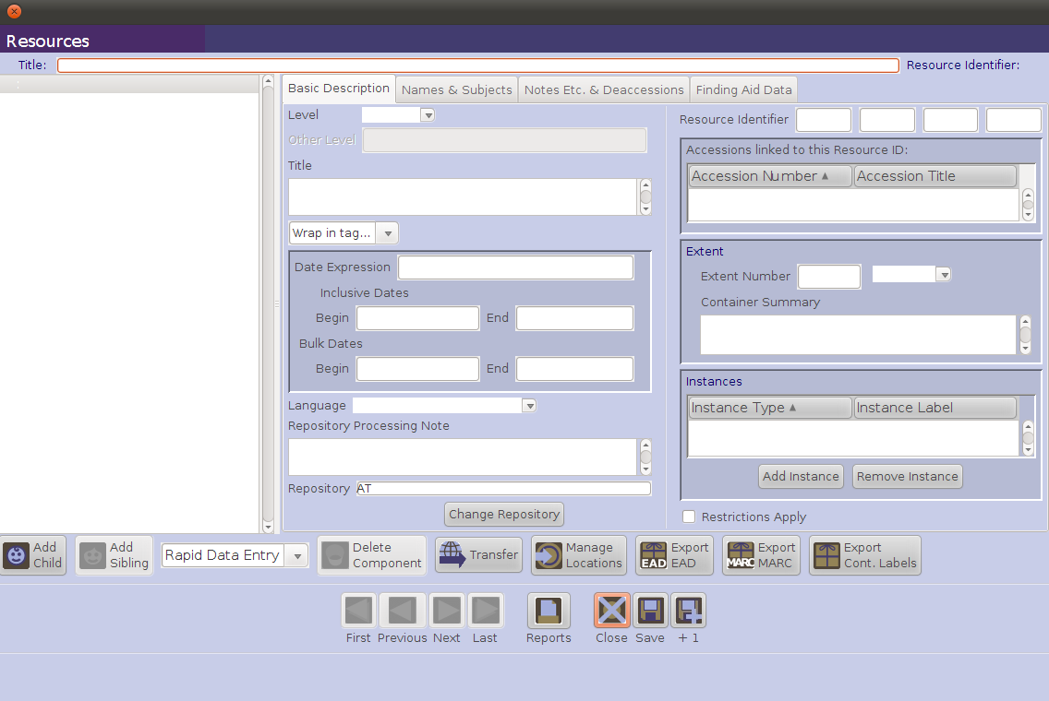
6
2
3
4
5
7
8

Spawning a Resource Record:

A resource record can be created from an accession record using the Link Resource function on the Basic Information tab of the Accession Record. Some, but not all, of the information recorded in the Accession Record will be copied to the newly created and linked Resource Record.

Note that you would typically spawn a resource record only from the first accession record for a specific resource (collection). Subsequent accessions to that resource can be linked to the existing resource record, but the resource record would need to be manually updated to reflect the accruals. Please be aware that it is not possible to use the spawn process to transfer data from an accession to an already extant resource record.

For first time accessions for newly acquired resources, think about the data you are inputting for the accession as the beginning of the Resource record. The more careful you are in formatting the accession data, the more work you can save when it comes time to create the resource record.

To create a linked and populated Resource Record from an Accession Record:
- Click on the Link Resource button
- Click on the Create Resource button in the Link Resource to Accession window

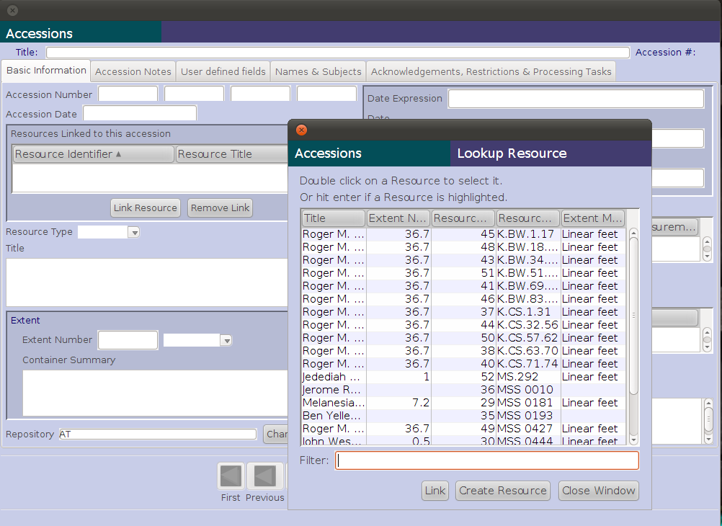
2
1

The resulting Resource Record will contain in its data fields some of the data recorded in the Accession Record on which it is based. The table below identifies what parts of the Accession Record are transferred to what parts of the Resource Record (see also Chapter 7 of the AT User Manual):

Accession Record to Resource Record Mapped Elements

Directly Mapped Fields

Accession Table Elements | Resource Table Elements
Field Label | Field Label
Title | Title
Extent Number | Extent Number
[Extent Measurement] | [Extent Measurement]
Container Summary | Container Summary
Date Expression | Date Expression
Date Begin | Date Begin
Date End | Date End
Bulk Date Begin | Bulk Date Begin
Bulk Date End | Bulk Date End
Restrictions Apply | Restrictions Apply
Repository | Repository
Indirectly Mapped Fields

Accession Table Elements | Resource Table Elements
Field Label | Field Label
Description | Scope and Contents Note
Condition Note | General Physical Description Note
Access Restriction Note | Conditions Governing Access Note
Use Restriction Note | Conditions Governing Use Note
Accession Number | Accession Number Linked
Title | Accession Linked
Name Linked | Name (Linked)
Subject Linked | Subject (Linked)

To complete and save the spawned Resource Record:

- Provide values for Level, Resource Identifier, Language, and other fields required for a valid Resource Record.
- Click on the Save button to save the resource record.
- Click on the Close button to close the resource record and return to the accession record. The link to the resource record will now be present in the accession record
- Click on the Close Window button to close the Lookup Resource window.
- Click on the Save button to close the accession record.
- Open the spawned resource record in the resource module to augment the resource description.

Additional description

Through the use of various notes, the description of an archival resource can be extended considerably. The AT supports 29 repeatable notes, which are available on the Notes, Etc. & Deaccessions tab on the Resource Record screen. Each note can be repeated as many times as necessary.

- Abstract
- Accruals Note
- Appraisal Note
- Arrangement Note
- Bibliography
- Biographical/Historical Note
- Conditions Governing Access Note
- Conditions Governing Use Note
- Custodial History Note
- Dimensions Note
- Existence and Location of Copies Note
- Existence and Location of Originals Note
- File Plan Note
- General Note
- General Physical Description Note
- Immediate Source of Acquisition Note
- Index
- Language of Materials Note
- Legal Status Note
- Location Note
- Material Specific Details Note
- Other Finding Aids Note
- Physical Characteristics and Technical Requirements Note
- Physical Facet Note
- Preferred Citation Note
- Processing Information Note
- Related Archival Materials Note
- Scope and Contents Note
- Separated Materials Note

To enter additional description:
- Select the Notes Etc. & Deaccession tab
- Open the Add notes etc. list and select a note to enter

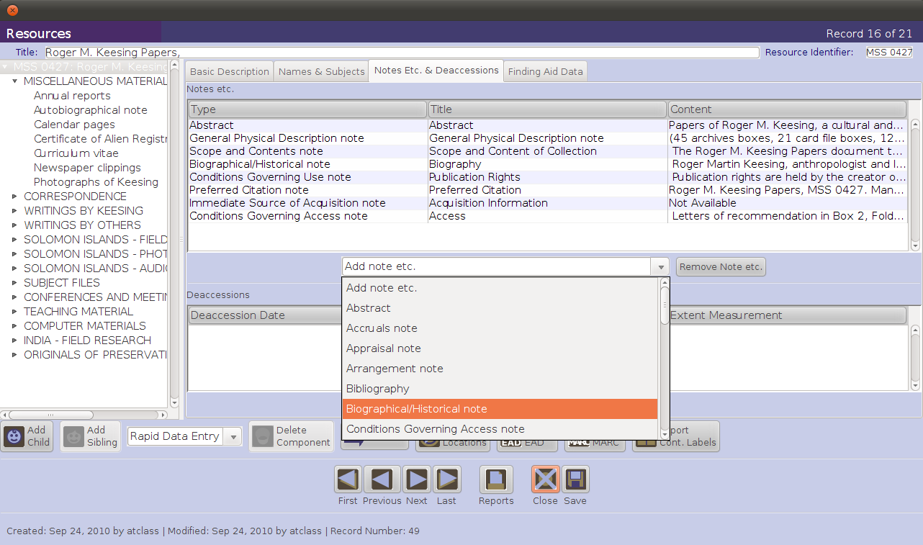
1
2

- Enter the note, including note label if desired. The default behavior is that the Note Type value will be used for the label unless a different label is provided.

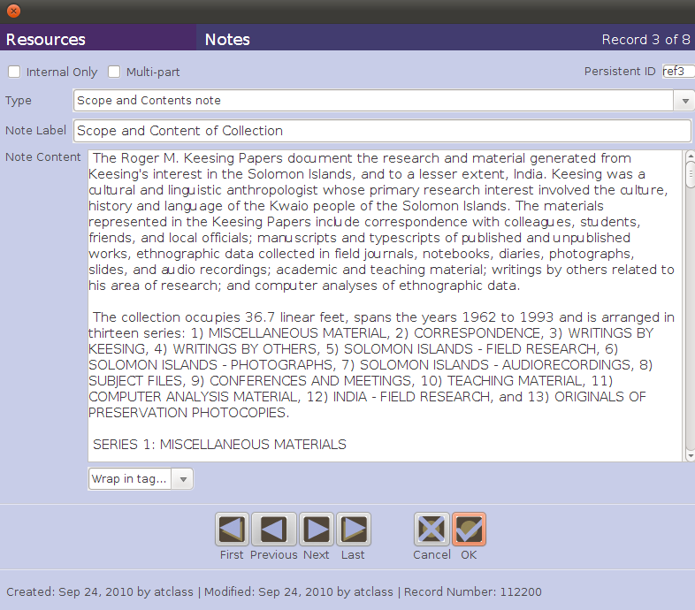
3
4

- Click OK when done, and the entered note will appear in the list of notes created for the description.

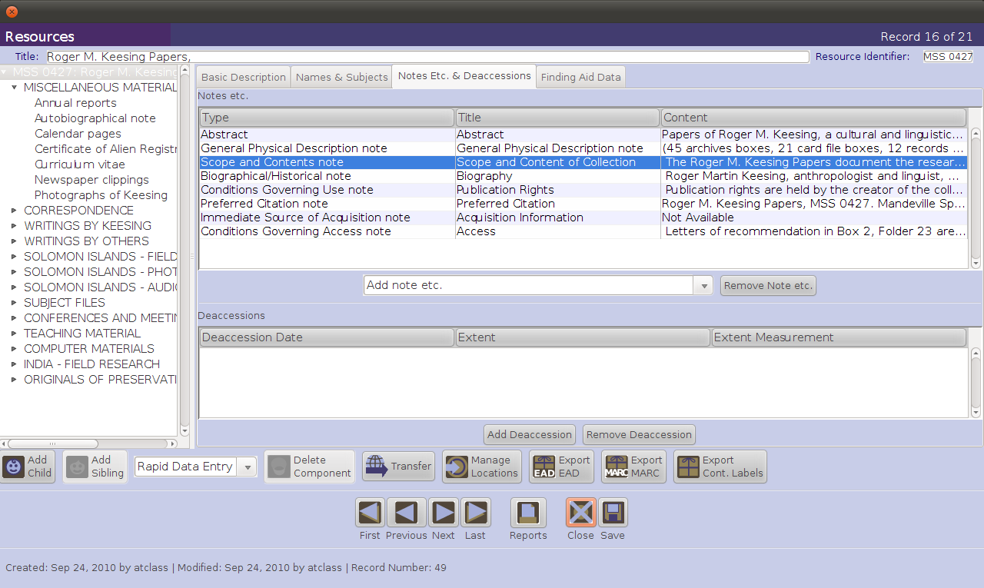

The above illustration shows eight different saved notes on the Notes Etc. tab. These notes may be rearranged by dragging and dropping them, within the Notes, etc. window, into the sequence that you want them to have in your AT exports and reports.

Adding Names and Subjects

Names of persons, families, or corporate bodies that have played a significant role in creating, using, and maintaining the archival materials are considered the source (creator) of the materials. These persons, families, or corporate bodies may also be represented topically in the content of the materials, as may other topical subjects describing what the materials are about. Terms representing all of these contextual and topical relationships can be added to the Resource description by linking name and subject records to it. This will be covered in a later exercise in this workshop.

Finding Aid Information

Information about the finding aid for the resource can also be added to the Resource record. This information is used to identify and provide bibliographic description data about the finding aid for the resource and should not be confused with description of the archival resource itself. Finding aid information is not required for a valid resource record, but it may be helpful for managing a repository’s finding aids.

To add finding aid information to the resource record:
- Select the Finding Aid Data tab
- Enter information for all pertinent fields
- Click Save to save the information as part of the resource record

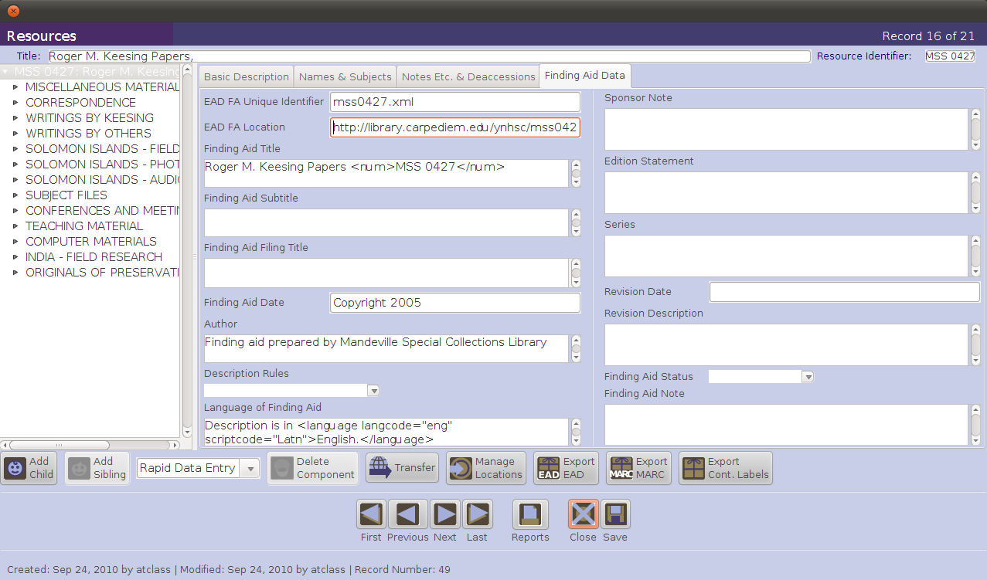
2
1

3

Exercise 5: Creating a top-level record for a resource

Using the Accession record you created for Accession 1986.014, “spawn” a Resource record.

Then, using information in the description sample “AT-Resource-exercise.doc” complete and enhance the parent Resource record “spawned” from Accession 1986.014.

Use the “Basic Description and Notes, Etc.” and “Deaccessions” tabs for this exercise. Include in the Resource record information about the finding aid (on the “Finding Aid Data” tab) that you expect to produce. You should not use the Names & Subjects tab at this point in the workshop.

Be sure to include relevant information for the recommended minimum elements for a multilevel description listed on page 10 of DACS. You will not, at this point, be supplying a Name of Creator(s) Element, but you should have sufficient information to supply all the other recommended minimum elements.

Create as many notes as you can based on the information supplied in the description sample.

In addition to description sample, you will likely find some combination of the following resources useful in completing this exercise:
- DACS.
- The Application of DACS to resource descriptions tables on pages 35-39 of this workbook will help you map DACS elements to specific AT Resource Record tabs and fields.
- Metrics:
  - 1 record carton = 1.0 linear feet
  - 1 audiotape box = .75 linear feet
  - 1 oversize folder = .65 linear feet
VIII. Resource description: multilevel (resource component) records, Instances, and the Rapid Data Entry Tool

The AT Resource Component record:

- Serves to describe the logical or physical parts of a resource that is made up of an aggregation of archival materials.
- Requires
  - Level - chosen from a pick list containing the values class, file, item, series, subseries, subfonds, subgroup, or other level. Note: typically you will not use the level values of collection, fonds, or record group for Resource Component records, since these are parts of a broader resource that will have one of those levels.
  - Either of the following fields
    - Title
    - Date

Like the Resource Record, the Resource Component Record accommodates extensive description of the component, including the same support for notes and controlled headings. You should use the guidelines for subsequent levels of description on pages 10-11 of DACS to help you determine which of the available AT fields should be used to insure that your descriptions meet the recommended minimum for a multilevel description.

The following are the command functions relating to components on the AT Resource and Resource Component Record screens:
- The Add Child button will open a new component record that is hierarchically subordinate to the context record (the record from which you use the Add Child button). For example, if your context record is a series and you want to create a subseries, file, or item within it, press this button.
- The Add Sibling button will open a new component record that is at the same level as the context record and that follows the context record within the sequence. If you are entering multiple series one after another in sequence, use this button to create the next series.
- The Delete Component button will delete the selected component and all of its children. If you wish to delete the component but not its children, you must reorder the child components first, so that they are no longer part of the component you wish to delete.

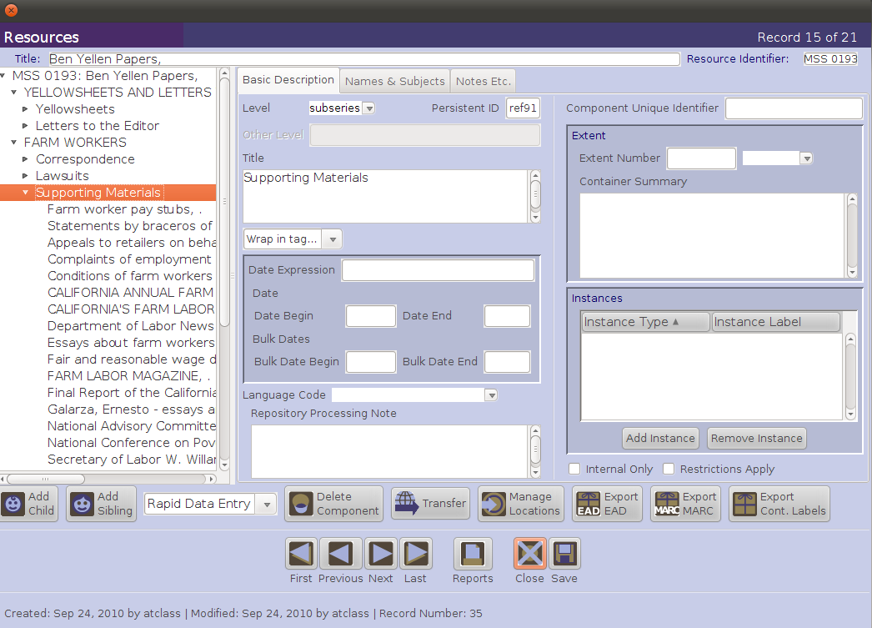
C
A
B

Steps in creating Resource Component Records for a Resource Description:

- From an open resource record, click on the Add Child button, or from an open component record, click on the Add Child or Add Sibling button.
- Select a Level for the component record (class, file, item, series, subseries, subfonds, subgroup, or other level).
- Enter a Title.
or
- Enter a Date Expression and/or Begin Date and End Date for the materials.
- Save the record by pressing the Save command button at the bottom right corner of the window.

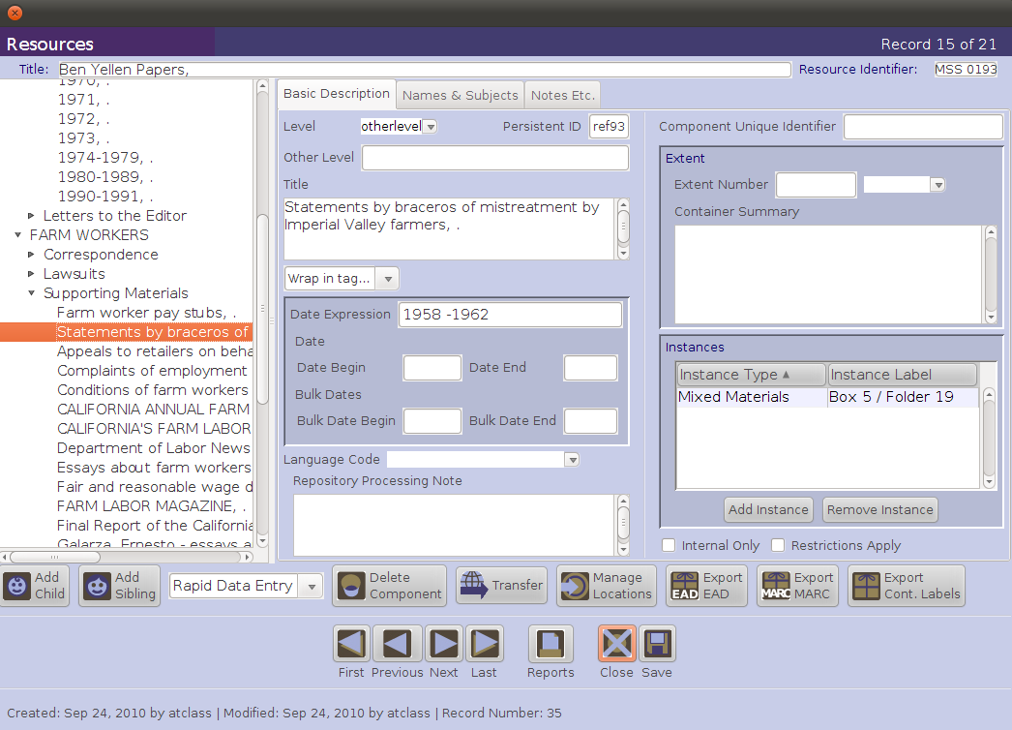
1
2
3
4
5

Adding Instances to the Resource Description

"Instances" in the AT refer to different states or embodiments of the described content. A resource record or resource record component (lower level in a multilevel description of a resource) may describe a letter, but the letter may exist as a sheet of paper, a microfilm image, and a digital object (i.e., the same described content exists in three instances). The AT is structured to allow you to use the same description for multiple instances rather than repeating it for each one.

This is not to imply that you can only create instances at the item level. Because archivists typically describe materials at aggregate levels, instances can also be created at any level in the AT– collection, series, file, etc.

In addition, an instance can represent analog materials or digital objects. In the case of analog materials, the instance record is where you record information about the physical containers that house the material being described, for example box, box and folder, or reel and frame numbers. This container information provides the “hook” for linking the content description to location records, allowing you to track physical locations of the containers that house the archival materials being described. For digital objects, the instance record allows you to describe the digital object and record information about the files that comprise it, as well as indicate its location on the web or within a file management system.

The instance data model supports assertions of the following type: the described content exists in this physical format, which is housed in this container and located at this place in the repository.

Note that digital media, such as a 3.5 inch computer disk or a CD-ROM that might be part of an archival resource, is not considered to be a digital object in the AT. Digital object records in the AT are intended to describe either digitized surrogates or born-digital materials that are stored on a server or other digital storage media that are available via a network.

The following steps illustrate how to declare an instance in the AT:
- From the Basic Information tab on the resource or resource component record, click on the Add Instance button.

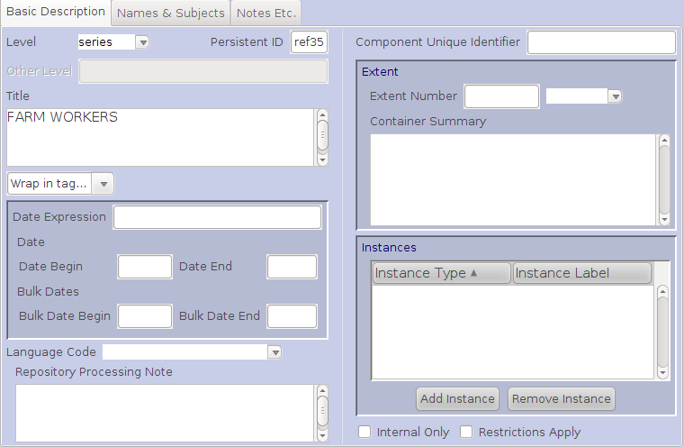
1

- Select the type of instance you wish to create and click on OK.

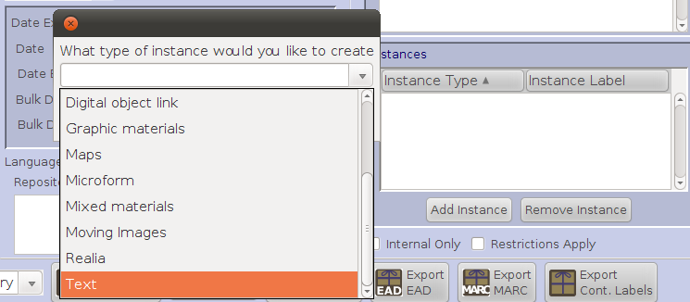
2
- For instances other than digital objects, you will be prompted for container information. You must at least select a value for Container 1 Type (for example, box, disc, reel, and volume are all potential values for this field) with a related Numeric Indicator or Alphanumeric Indicator and/or supply a value for Container Barcode.
- You may record a Container Type, Numeric Indicator, or Alphanumeric Indicator for up to two containers nested within your Container 1
- Press OK to save the container and instance records.
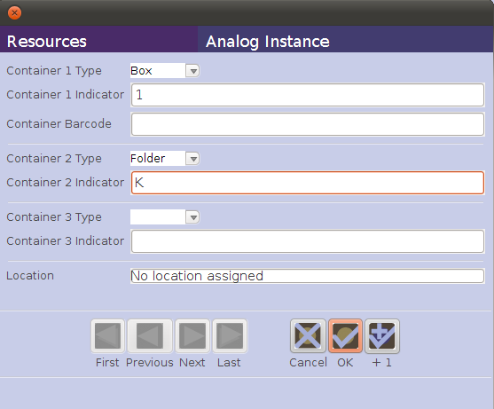
- The instance declaration and container information will be displayed in the resource record or resource component record.
3
4
5
6
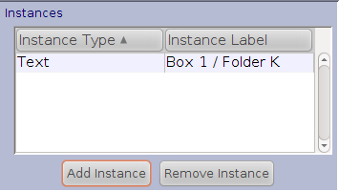

- Once you have recorded instance and container information, you can assign a location to each primary container by clicking the Manage Locations button.

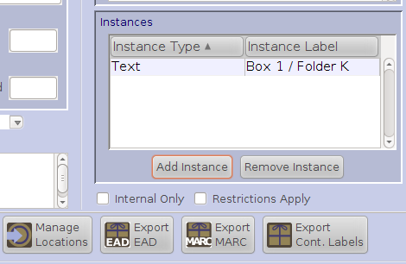
7

Using the Rapid Data Entry (RDE) Tool to create Resource Component Records:

The RDE tool supports repeated entry of Resource Component Records at the same level, requiring fewer mouse clicks than when adding individual component records and then adding instance records. Through the use of “sticky values,” the RDE tool provides a more efficient interface for entering series or folder lists, where multiple components of the same level and same basic content are entered one after another. Note: the RDE tool can be customized for different kinds of components for different situations, e.g., series-level components vs. item-level components.

- Press the Rapid Data Entry button on the Resource or Resource Component Record screen.
- Select the Rapid Date Entry template to be used. (The AT ships with one default template. Many more can be constructed for different kinds of situations such as creating series- or item-level components.)
- Enter desired data. The Level element and either Title or one of the Date elements is required.
- Instance type and at least one container type/number are necessary if locations are to be linked to the resource
- Press OK, or to enter another component, +1.

Top Half of RDE

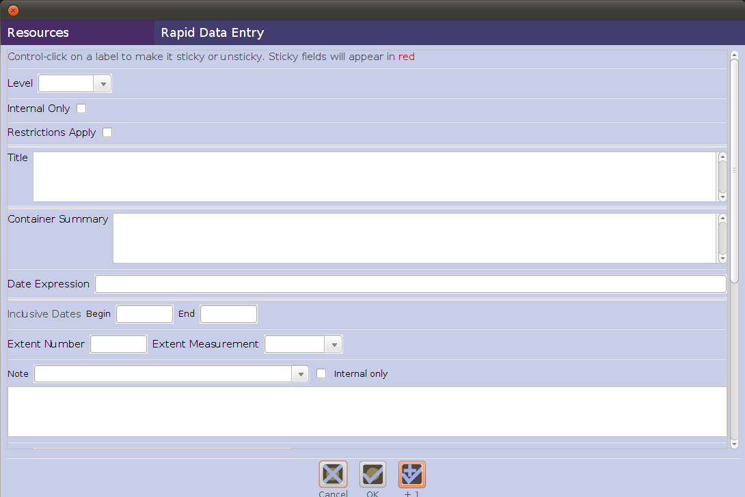
32
33
3

Bottom Half of RDE

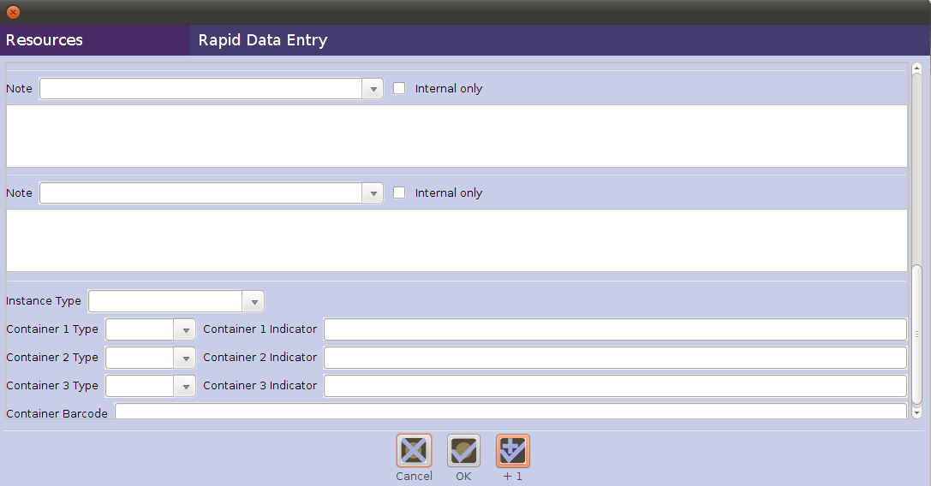
4
5

Exercise 6: Creating a multilevel record for a resource

Add Component records to the description resource for Wayward family papers, using the table in the Description Sample as the source of your information.

Organize your work in a manner that will take advantage of the series- and file/item-level component RDE templates made available for the workshop. The series-level RDE is designed to support the addition of series-level component records; the template does not support the addition of instance information. The processing policy of YNHSC is to provide the following for each series component record:
- Component Unique Identifier (e.g. Series 1, Series A, etc.)
- DACS-compliant title
- Inclusive dates
- Extent
- Scope / Content note
- And other data elements as needed.

The file/item-level RDE is designed to support more substantial records and does support adding instance information. You should use this RDE template for components that need to be connected to instance/container records.

You should be able to add four series-level records. The Grover Allen Wayward materials will likely be the most detailed of your component records for the Wayward family papers.

Be sure to add notes where pertinent.
Be sure to have appropriate containers for the entire collection.

You should use DACS and the Application of DACS to resource descriptions tables on pages 35-39 of this workbook as you work through this exercise. Think about the data content for the AT fields you are filling in. Especially look at DACS' recommendations for data elements at subsequent levels of a multilevel description (on pages 10-11 in DACS) and make decisions based on that about the AT fields in component records that you really should fill in.

IX. Subject and other controlled vocabulary records

Function of subject and other controlled vocabulary records within the Archivists' Toolkit:

Records for subjects and other controlled vocabularies are used to record and control information about topics, geographic names, genre and form terms, occupations, functions, and uniform titles that serve as important access points to facilitate discovery of the materials being described. These records are established and controlled separately from resource descriptions in the AT and are associated with accession, resource, and digital object descriptions by linking.

These types of terms meant to serve as access points for collection materials function most effectively when derived from broadly shared standard thesauri or controlled vocabularies such as the Library of Congress Subject Headings (LCSH) or the Art and Architecture Thesaurus (AAT). The output formats (e.g., EAD, MARCXML) that you generate from your resource descriptions in the AT will be much more effective if you utilize standard thesauri or controlled vocabularies to select terms, and document your usage locally so that you can apply common terms, as appropriate, in a consistent manner across all of your resource descriptions.

Subjects can be one of six types in the AT:
- Function
- Genre/Form
- Geographic Name
- Occupation
- Topical
- Uniform Title

Names that are used as subjects are managed as name records in the AT; therefore a name type is not an option within subject records.

Subject records can be linked to accession records, resource descriptions, resource component descriptions, and digital object records in order to provide subject and other types of controlled vocabulary access to those materials at all appropriate levels of granularity, and at whatever points in local repository workflows this type of description is done.

Note: subjects linked to accession records, resource component, and digital object component records will not be exported into MARCXML records.

Application of DACS to subject and other controlled vocabulary records:

There are no rules in DACS applicable to the creation of subject and other controlled vocabulary records in the Archivists' Toolkit. The discussion of Access Points on pages xviii-xxi in DACS provides useful advice regarding specific DACS elements whose content may provide names, places, topical subjects, documentary forms (genres), and occupations that should be considered as formal access points. One important concept from bibliographic cataloging that should guide your selection of subjects is that of justification of access points in notes. Basically, if you haven't mentioned a name, place, topic, or documentary form in a note in one of your DACS-specified elements of description, you probably should not be linking that subject to your Resource record (or you should go back and edit your description to include information about that subject if you determine that it is indeed important enough to use as an access point).

You or someone at your repository should be familiar with the rules for using the specific thesaurus, authority file, or controlled vocabulary (data value standards) from which you derive the forms of names that you utilize to represent these access points on the Names & Subjects tab on an AT Accession Record, Resource Record and its components, or a Digital Object Record and its components. Appendix B, on pages 209-212 in DACS, provides a helpful list of the primary data value standards used by U.S. archivists in doing archival description.

Creating subject and other controlled vocabulary records in the Archivists' Toolkit:

The following data fields are required when creating a subject or other controlled vocabulary record in the AT.

- Subject Term is the data field that contains a controlled vocabulary descriptive term or phrase describing the content, coverage, or resource type of the materials – a descriptor that indicates the content or type of resource. This field allows for simple terms and phrases entered as character strings, as well as those entered with separation devices such as the double dashes (--) typically used to separate the components of LCSH terms. The Toolkit does not, however, enforce consistency in the use of separation devices. Because the entire subject string is entered as a single data element, it will be necessary to edit some outputs where individual subfields are important (for example, hierarchical subject headings expressed in MARCXML).
- Subject Type is the data field that indicates the type of term being recorded (i.e., function, genre/form, geographic name, occupation, topic, or uniform title). The content of this field is selected from a drop-down list. In addition to the subject type, the list provides the MARC-field equivalent for that type. For example, a geographic name type corresponds to MARC field 651 and a genre/form type corresponds to MARC field 655.
- Subject Source is the data field that identifies the thesaurus or controlled vocabulary from which the term was taken, giving the authority for the term. The content of this field is selected from a drop-down list derived from what was at the time the Library of Congress MARC Code List Part IV: Term, Name, and Title Sources. Items may be added or deleted from the list to meet the needs of the repository. The option Local is available for cases when the term used has not been derived from one of the thesauri or controlled vocabularies provided in the list, and is maintained in a local list of preferred terms.

The following data fields are optional when creating a subject or other controlled vocabulary record in the AT.

- Scope Note is a data field that can be used to extend the AT record for a subject or other controlled vocabulary term by recording a scope note to indicate how a term should be applied within your institution. It is particularly useful to state the scope of local terms and provide additional information on the warrant or authority for those terms.

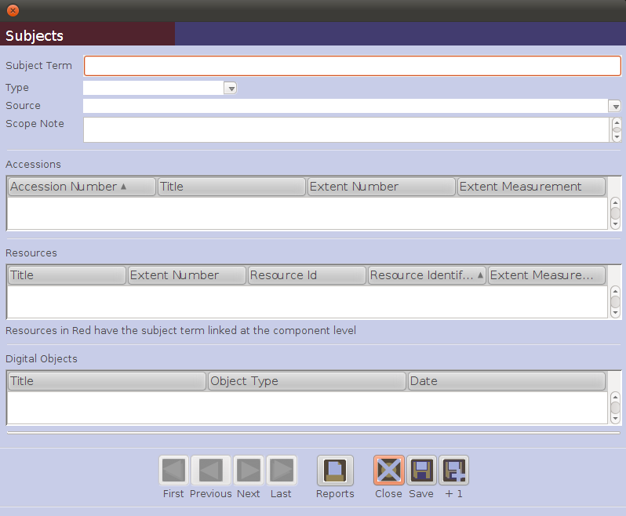
1
2
3
4
Exercise 7: Creating subject and other controlled vocabulary records for a resource

Using the Wayward collection description that you have so far completed in the AT, determine subjects (i.e., topics, places, events, documentary forms/genres, occupations) that you want to provide access headings for and then create a subject record for each one.

By this point, you should have captured all important, relevant information from the Description Sample handout in fields in the AT. Base your selection of subject access points on the various parts of your Wayward Resource Record in the AT and not from the handout.

At this point do not supply any personal, family, or corporate names as subjects.

The previously mentioned discussion of selecting Access Points in DACS (pages xviii-xxi) will be helpful in this exercise.
The following online resources may also be helpful in this exercise:
  - The Library of Congress Subject Headings, available at http://authorities.loc.gov/
  - The Getty Art and Architecture Thesaurus, available at http://www.getty.edu/research/tools/vocabularies/aat/index.html
  - The Getty Thesaurus of Geographic Names, available at http://www.getty.edu/research/tools/vocabularies/tgn/index.html
  - The Library of Congress Thesaurus of Graphic Materials, Part I: Subject Terms, available at http://www.loc.gov/rr/print/tgm1/toc.html
  - The Library of Congress Thesaurus of Graphic Materials, Part II: Genre & Physical Characteristic Terms, available at http://www.loc.gov/rr/print/tgm2/toc.html

X. Name (corporate, personal, and family) records

Function of name records within the Archivists' Toolkit:

Name records are used to record and control the corporate, personal, and family names associated with archival materials and deemed important enough in the context of those materials to serve as access points for their discovery. Names are established and controlled separately from resource descriptions in the AT and are associated with collections by linking. This allows archivists to track relationships between collections and the various significant persons, families, and corporate bodies that may have been sources or creators of records, or subjects within the collection materials.

Names have three functions in the AT:

- Creator. Designates the primary responsibility for the material being described. Creator can encompass, at varying levels in a multilevel description, the person, family, or corporate body responsible for the archival provenance of the material being described, or for the intellectual content of that same material.
- Source. Designates the immediate source of acquisition of the materials being described.
- Subject. Designates that the materials being described are topically about the named person, family, or corporate body in some respect.

Names can be one of three types in the AT:

- Person
- Family
- Corporate Body

Name records in the AT are designed to conform with the International Council on Archives’ International Standard Archival Authority Record for Corporate Bodies, Persons, and Families, 2nd edition (ISAAR(CPF)). They are also designed to support output in the data standard Encoded Archival Context (EAC). Name records also accommodate the creation of names according to data content rules established in standards such as the Anglo-American Cataloging Rules, 2nd edition (AACR2) and Describing Archives: A Content Standard (DACS). AT users are encouraged to use the DACS rules for forms of names when creating name records in the AT.

Names can be linked as creators and subjects in accession, resource, resource component, and digital object records. Names can be linked as sources in accession and resource records only. (This information can be captured in an “Immediate source of acquisition” note at any level of a resource description, however.) Note: as with Subjects, Names linked to accession records, resource component records, and digital object component records will not be exported to MARCXML records.

Application of DACS to name records:

There are several ways in which DACS can assist you in utilizing Name Records in the AT.
- The rules in DACS Chapter 9 (pages 89-92) will help you in determining which name(s) should be linked to your Resource Record in the role of Creator(s). Making this link will fulfill the recommendation that all minimum DACS records have at least one Name of Creator(s) Element (DACS 2.6).
- If you are working in a system that can utilize the ability of the AT to create ISAAR(CPF)-compliant archival name authority files, the rules in DACS Chapter 11 will help you to construct data content for the fields in an ISAAR(CPF)-compliant record.
- The chapters in DACS Part III, Forms of Names, will provide useful guidance for formatting the names of persons, families, and corporate bodies for which you cannot find existing authority records in national name authority databases such as the Library of Congress NACO (Name) Authority File.
  - Chapter 12 provides rules for formulating the names of persons and families.
  - Chapter 13 provides rules for formulating names of geographic entities that may also be the name (or form part of the name) of corporate bodies.
  - Chapter 14 provides rules for formulating names of corporate bodies.

Creating name records in the Archivists' Toolkit:

The AT requires that the type of name (personal, family, or corporate body) be identified on input using a drop-down list.

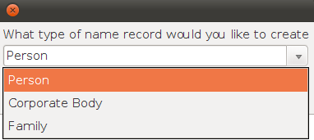

In addition, depending on the type of name, the following fields are required:

- Personal:
- Primary Name (DACS references 9.8, 11.5, 12.1-12.11)
- Source (DACS reference 11.26) or Rules (DACS reference 11.20)
- Sort Name (automated if selected)
- Corporate Body:
- Primary Name (DACS references 9.8, 11.5, 14)
- Source (DACS reference 11.26) or Rules (DACS reference 11.20)
- Sort Name (automated if selected)
- Family:
- Family Name (DACS references 9.8, 11.5, 12.29)
- Source (DACS reference 11.26) or Rules (DACS reference 11.20)
- Sort Name (automated if selected)

For Personal names, the AT Primary Name field serves to separate the principal sorting element of the name from the remainder of the name, the latter of which is generally input into the AT Rest of Name field. Guidance on when to use the additional AT fields that are available for a Name Record should come from a content standard such as DACS or AACR2, or from the subfields in an authority record for the name found in a national database such as the NACO Authority File.

For Family names, the AT Family Name field serves to hold the family name. Rules in a content standard or subfields in an existing authority record should guide you in inputting information into the AT Name Record's available fields.

For Corporate names, the AT Primary Name field holds the principal name by which the corporate entity is known. Your content standard of choice, or the subfields in the authority record for names already found in an authority file, will provide guidance to help you determine how and when to enter a corporate name subordinately using the Subordinate name fields on the AT Name Record.

Source is the data field used to indicate that a name has been found in a standard authority file. The Source field contains a code for the relevant authority file.

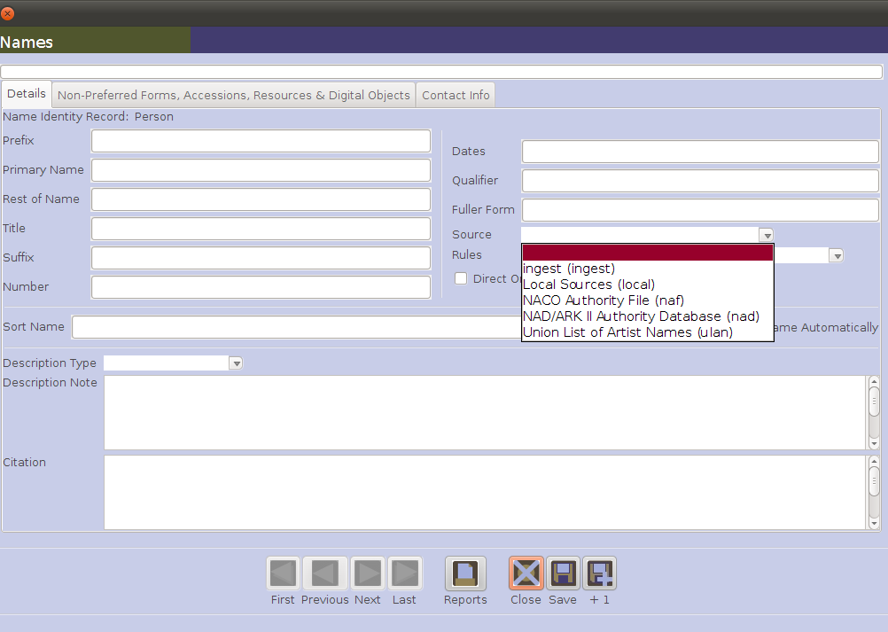

Four default values are provided in a drop-down menu:
- local. Designates an authority file created and maintained at your repository.
- naf. Designates the NACO bibliographic authority file.
- nad. Designates the National Authority Database of Sweden.
- ulan. Designates the Union List of Artist Names.
This list may be customized and additional values added. If names are imported in accession or resource records, the Source field will contain the value ingest for those names, until the name is modified and the source is changed to is appropriate value. This is to flag the record for review to assure it is the authoritative form of the name.

Rules is the data field used to indicate the data content standard used to formulate the name entry. You should only use the AT Rules field when you have not found the name in an existing authority file, in which case you should use the AT Source field instead.

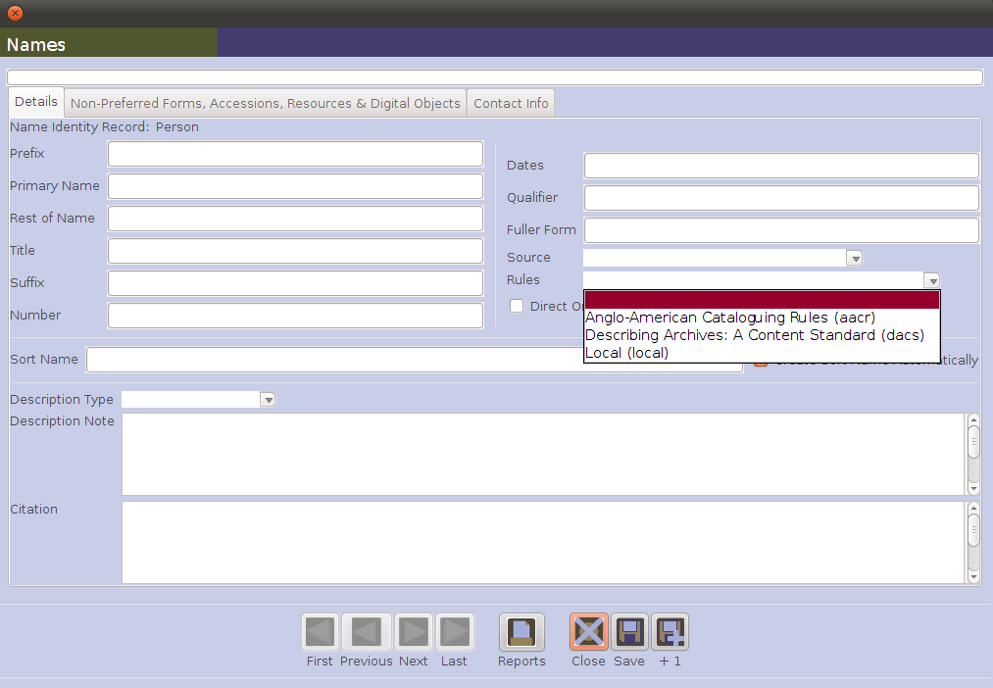

Three default values are provided in a drop-down menu:
- aacr. Designates the Anglo-American Cataloging Rules, 2nd edition.
- dacs. Designates Describing Archives: A Content Standard.
- local. Designates a data content standard created and maintained by your repository.
This list may be customized and additional values added by the repository, or in the process of importing legacy data.

Sort Name is the data field that contains the complete, concatenated version of the name containing all individual elements. This is the form of the name that will be shown within AT displays and is exported in reports and standardized outputs such as MARCXML and EAD. Checking the "Create Sort Name Automatically" box on a new AT Name Record is a good way to visually see that the various data entry fields are coming together in a meaningful, standards-based output string.

Creating basic name records:

- Determine the authoritative form of the name based either on finding it in an authority file, or on rules from a data content standard.
- From the Main Screen, select Names and press the New Record button.
- Select the type of name record from the drop-down list: Person, Corporate Body, or Family.
- Enter the Source of the name, if found in an authority file, or if not found in an authority file indicate the Rules used to construct the name.
- Enter the authoritative form of the name in Primary Name (for a personal or corporate body name) or the Family Name.
- Save the name record by pressing the Save command button at the bottom right corner of the window. If entering more than one name record, save the record by pressing the +1 command button. This will save the current record and open a new name record screen so a subsequent record can be entered.

In addition to these required fields, the following additional fields are available on the Non-Preferred Forms, Accessions, & Resources tab and the Contact Info tab for capturing additional details about names:
- Non-Preferred Forms of names.
- Linked Accessions and Resources.
- A variety of fields to record contact information.

Note: When working within accession, resource, resource component, and digital object records you can link to an existing name record or create a new name record that you wish to associate with that material, without having to exit the accession, resource, or digital object record.
Examples of Name Records

Corporate Name: Details tab

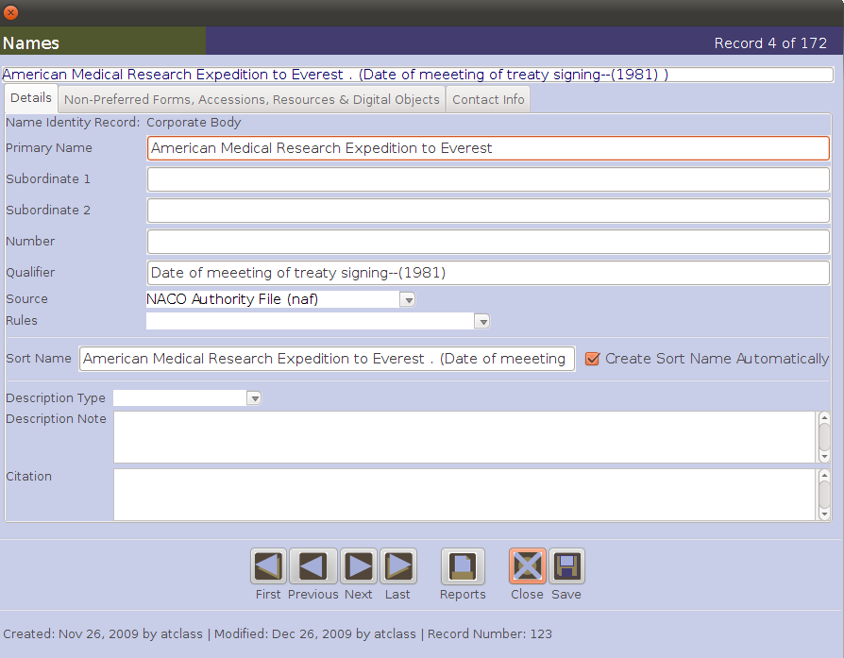

Family Name: Details tab

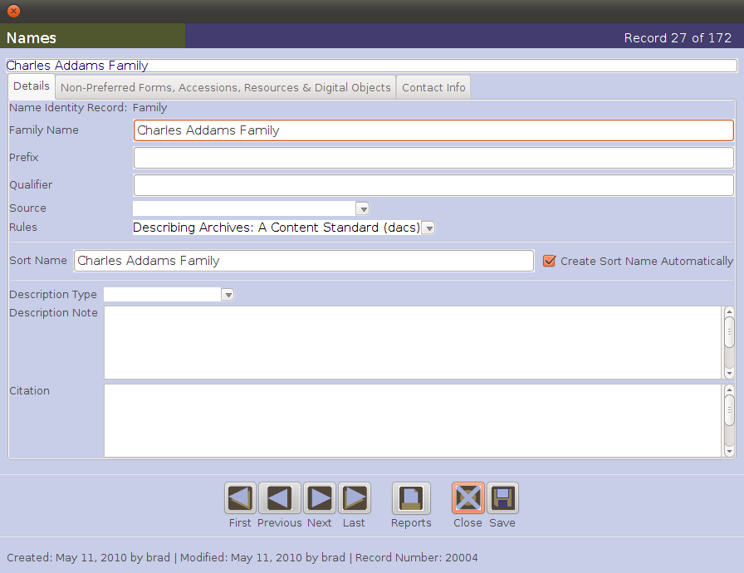

Personal Name: Details tab

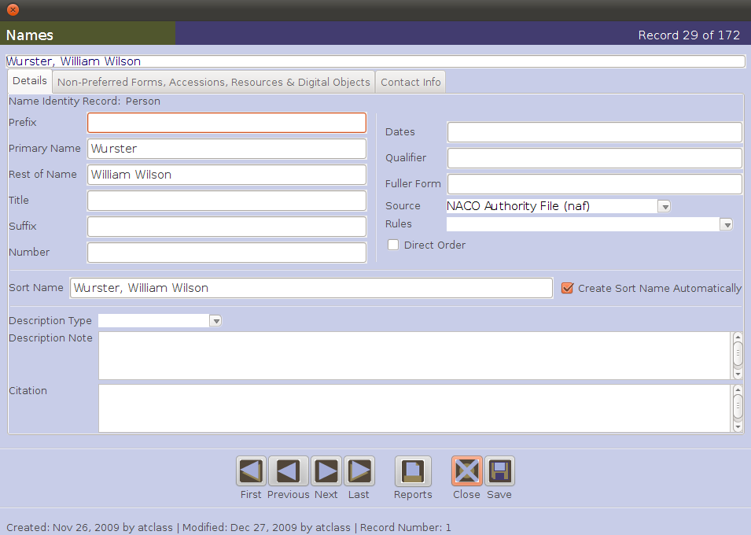

Non-Preferred Forms, Accessions & Resources tab

All three name record templates include a tab for recording non-preferred forms. The template for recording non-preferred form names is by and large identical to the details tab for each type of name.

Also, the Non-Preferred Forms, Accessions & Resources tab will list all the accessions, resources, and digital objects to which the name has been linked.

Below is an example of the Non-Preferred Forms, Accession & Resources tab for the Name Record for Persons.

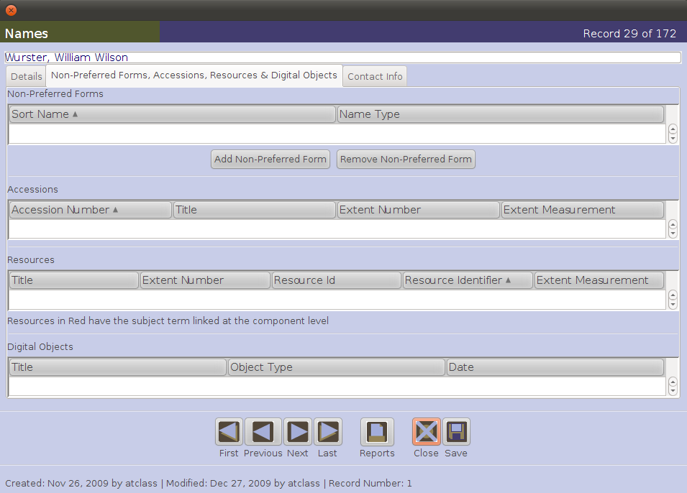

Contact Info tab

Each name record also includes a Contact Info tab, which supports two main functions.

One function is to record contact information about the entity identified in the name record. The contact information may be directly for the entity identified in the name record or an entity that serves as the contact, i.e., an administrative assistant for a CEO.

Another function is to record, in journal-like fashion, interactions with the entity identified in the name record, or with the designated contact. These interactions might, for example, pertain to repeated conversations and visits regarding the appraisal and eventual acquisition of a resource.

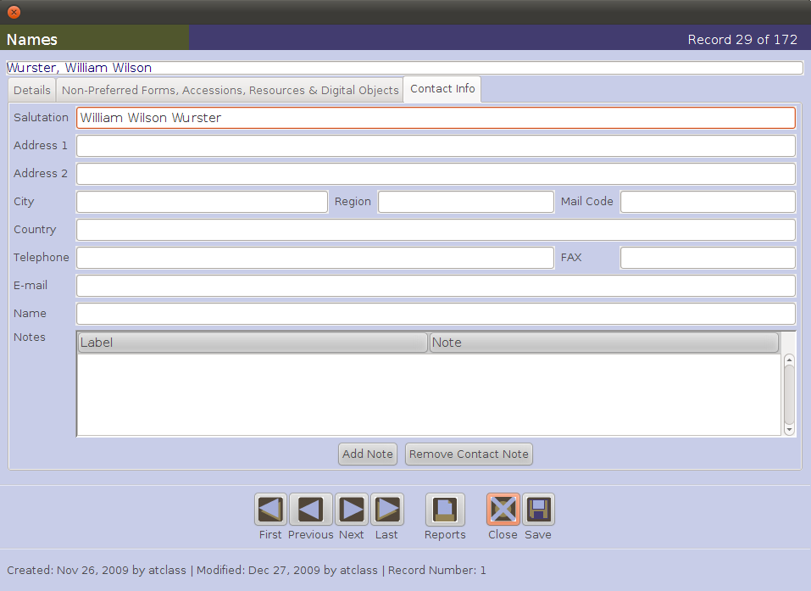

Exercise 8: Creating name records for a resource

Using the Wayward collection description that you have so far completed in the AT, determine the entities that you want to provide name access headings for, determine the type of name (personal, corporate body, family), and then create a name record for each one.

By this point, you should have captured all important, relevant information from the Description Sample handout in fields in the AT. Base your selection of access points from the various parts of your Wayward resource record and not from the handout.
Be sure to indicate the relevant Source or Rules for each Name record that you create.

At this point it does not yet matter whether these personal, family, or corporate names are creators, sources, or subjects. You are just creating the name records in this exercise. Later, you will link them up to specific resource records with specific functions specified.
The previously mentioned discussion of selecting Access Points in DACS (pages xviii-xxi) will be helpful in this exercise.

The following online resources may also be helpful in this exercise:

The NACO (Library of Congress) Name Authority File, available at http://authorities.loc.gov/

Virtual International Authority File (VIAF), available at http://viaf.org/
XI. Linking description parts

Linking records adds to the description and assists in the management of archival materials. Linking name or subject records to the resource record helps reveal the context and content of the archival materials. These linked headings also provide access headings to export in EAD, MARCXML, and METS records. In addition, linking location records to the resource record facilitates retrieving and reshelving the archival material without having to rely on another tool external to the AT.

Linking records also makes data management easier. One name record or one subject record can be linked numerous times to a resource record or to numerous resource records. Modifying the linked name record or subject record means the changes will appear in all places in the AT where the record is linked. This technique also reduces the chance of errors and variations being introduced into the data due to multiple re-keying of the same data.

Names and subjects may be recorded and linked as part of the process of building a resource description, or, using the New Record function in the name or subject module, they may be entered into the AT in advance of doing a specific resource description.

Removing a link for a name, subject, or other record simply removes its relationship to a certain accession record or part of a certain resource record. The record’s link to other accession or parts of resource record(s) will remain intact and operable. On the other hand, deleting a name, subject, or location record will break its links to all other records.

To link name records to accession, resource, or resource component records:

- From the Names & Subjects tab of an accession, resource, or resource component record, press the Add Name Link button.
- The AT will display a Name Lookup window containing a list of names already recorded and available for linking to the accession, resource, or resource component record. To locate a particular name, either scroll through the list or begin to type the name in the Filter box. As the name is typed, the list will be filtered to include only those terms matching the string entered into the Filter box.

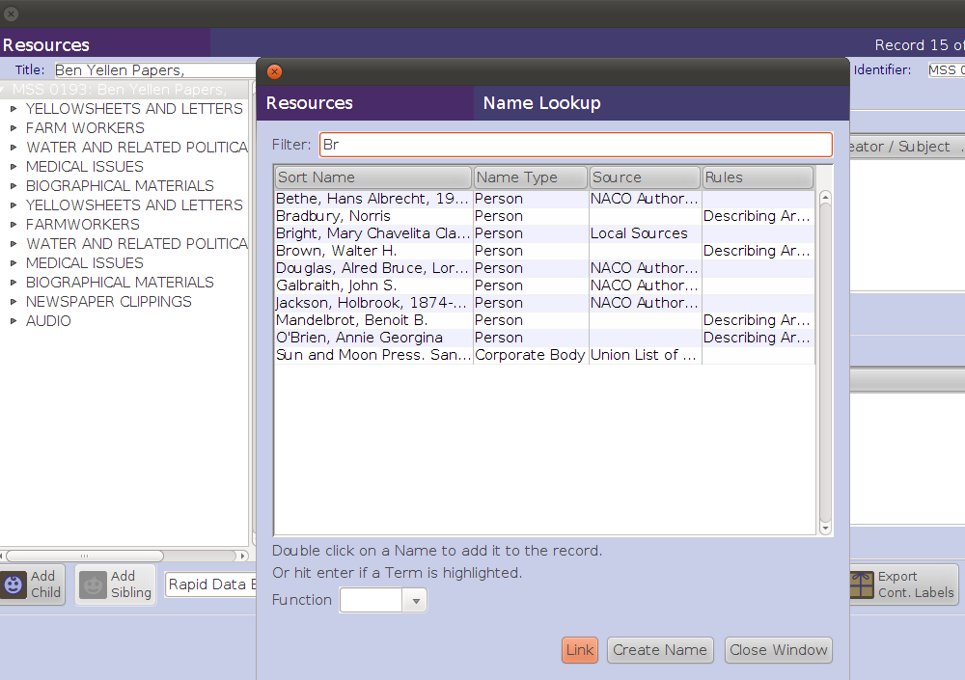
4
2
5

- If the desired name appears in the list, select it.
- If the desired name does not appear in the list, you may record it by pressing on the Create Name at the bottom of the Name Lookup window. Follow the instructions above for creating new name records.
- Once a name is selected, choose a Function for the name from the pull-down menu, either Creator, Source, or Subject. This step is required, as a name may not be linked without declaration of the name’s function in relationship to the accession, resource, or resource component record to which it is being linked.
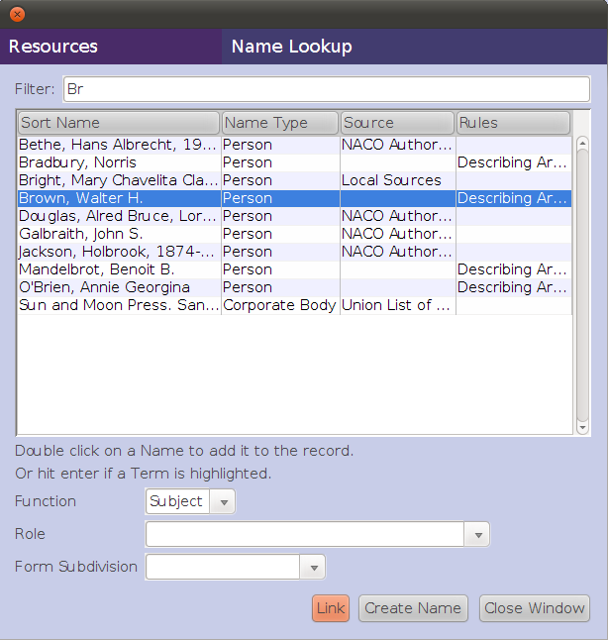
6
7
8
9

- If useful, a more specific Role may be selected for indicating the role of the name in relationship to the materials described in the accession or resource / resource component record.
- For names linked with the function of subject, a Form Subdivision may also be selected for the name.
- Once you have selected a name and its function, and optionally its role and form subdivision, press the Link button. The name will be added to the Names window of the accession, resource, or resource component record.
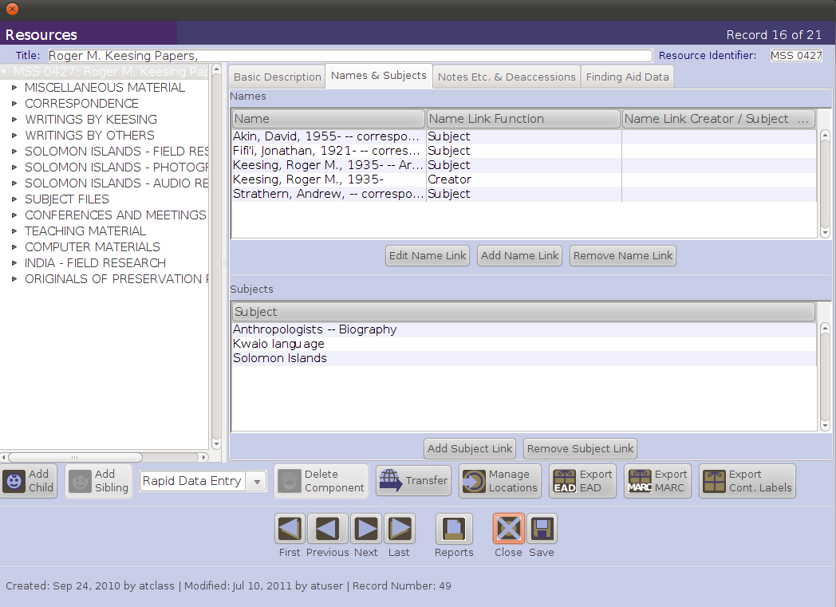

- Repeat the process of selecting or adding names as often as necessary. Then press the Close Window button to return to the accession, resource, or resource component window.

Note: it is possible to link multiple names at one time providing the names have the same link attributes for function, role, and/or form subdivision.

To link subject records

- From the Names & Subjects tab of an accession record or of a resource or resource component record, select the Add Subject Link button.
- The AT will display a list of subject terms available in a Subject Term Lookup window. Scroll or filter through the list of subjects to determine if the desired subject is already recorded or needs to be added to the AT.
- If the subject has been recorded, select it and either click on the Link button or double click on the term, to link the subject to the accession, resource, or resource component record. Note: It is possible to link multiple subjects, contiguously sequenced or not, in the Subject Term Lookup window to the accession, resource, or resource component record through the use of the Command or Shift keys.
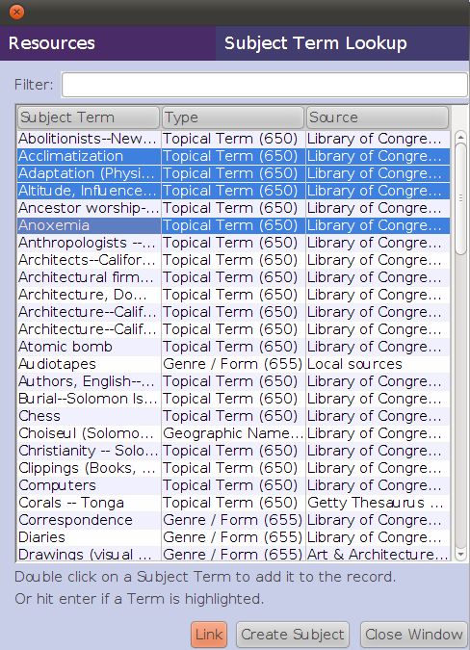

- If the sought after subject has not been recorded, and if you are have the appropriate permissions in your local AT installation, you may record the term by clicking on the Create Subject button and completing the subject record per the instructions for recording subjects above.
- Following either method, the linked subject will appear in list of subject terms linked to the accession, resource, or resource component record.
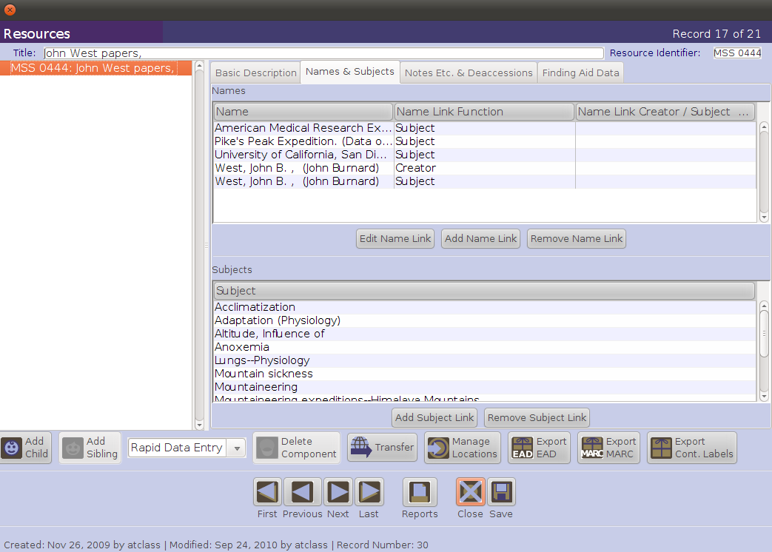

- Repeat the process of selecting terms as often as necessary. Press the Close Window button to return to the accession, resource, or resource component record.

Subjects may be recorded and linked as part of the process of building a resource description, or, using the New Record function in the subject module, may be entered into the AT in advance of creating a resource description.

To link location records:

- Open the resource or resource component record to be linked to a location.
- Press the Manage Location button.
- The AT will display a window listing all containers recorded for the resource or resource component in the Containers part of the window, and all locations available for the repository in the Locations part of the window. Select one or more containers.

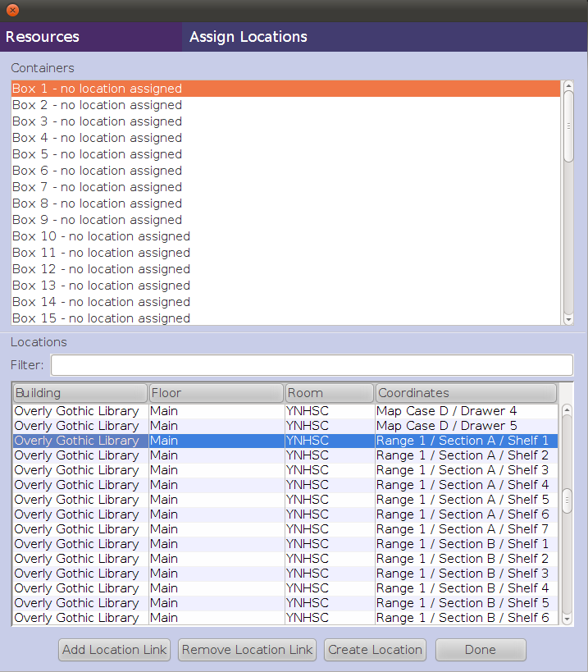
3
4
5

- Select the location to be assigned to the selected containers.
- Press the Assign Location button.
- You will see the location listed next to the container(s) in the Containers window.
- Once all locations have been linked to the resource record, press the Done button.
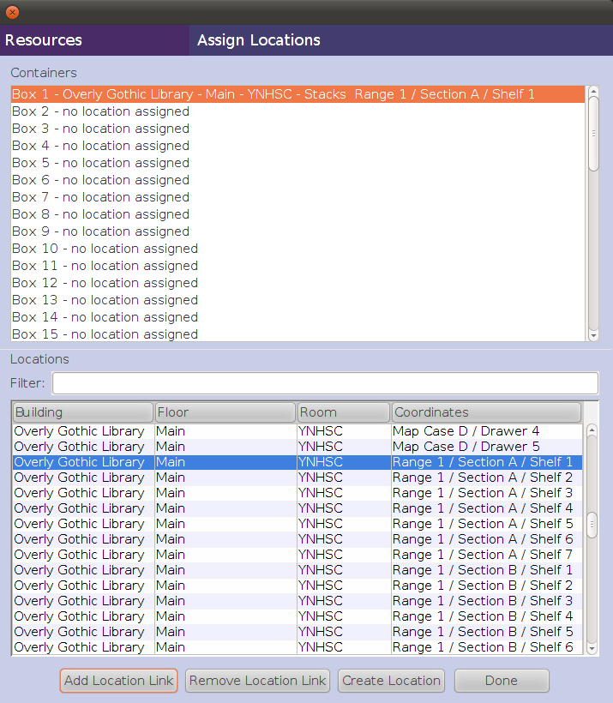
6
7
Exercise 9: Linking parts of a description for a resource

Link all the Name records and Subject records to the appropriate parts of the resource description you have created for the Wayward Family Papers.

Assign all containers (instances) in the Wayward Family Papers Resource records to appropriate locations in the YNHSC repository stacks, using the locations you created.
XII. Importing legacy data

The Archivists’ Toolkit supports the importing of certain legacy data in order that repositories may have all of their archival collection information under common management in one application.

Currently, the AT supports importing the following kinds of legacy data:
- Accession data in tab-delimited or XML format.
- EAD 2002 valid to either the DTD or the Schema.
- Valid MARCXML.
- Digital Object data either as part of EADs (<dao>) or tab-delimited

All legacy records except MARCXML can be batch imported.

It is anticipated that future developments of the AT will support the import of names and subjects independent of Accession, EAD, or MARCXML records.

Importing Tab-Delimited Accession Data:

Accessions data must be able to create a valid AT accession record. That is, each legacy record imported must have at least a unique accession number and an accession date.

- From the Import menu select Import Accessions (Tab delimited).
- Make the following selections:
  - Choose the file to be imported.
  - Select the repository for which the accession data applies.
  - Indicate the format of the dates contained in the file to be imported.
  - Select the appropriate Resource record creation option.
    - Do not create resource record.
    - Create resource record with resource ID only.
    - Create resource record using all fields (See Chapter 7 of the AT User Manual for a list of the data fields in the accession record that can be multi-purposed to the resource record on import of accession records or later).
- Click Import to begin.

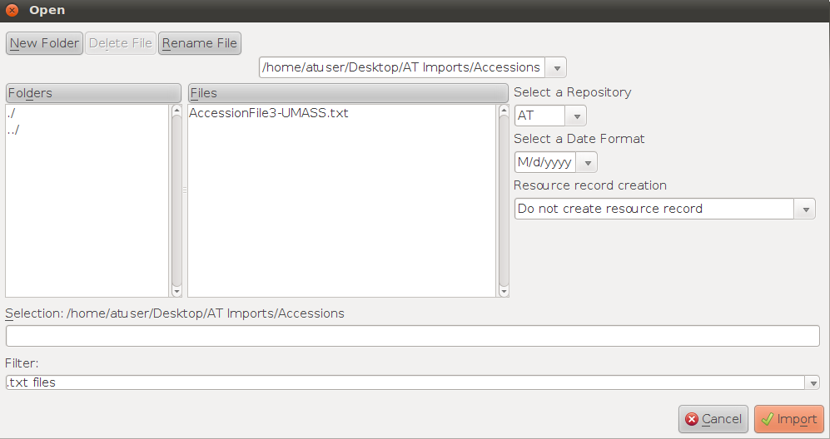

Importing XML Accession Data:

- The legacy accession data must be in XML format conformant to the accessions.xsd distributed with the AT.
- From the Import menu select Import Accessions (XML).
- Make the following selections:
  - Choose the file to be imported.
  - Select the repository for which the accession data applies.
  - Select the appropriate Resource record creation option.
    - Do not create resource record.
    - Create resource record with resource ID only.
    - Create resource record using all fields (See Chapter 7 of the AT User Manual for a list of the data fields in the accession record that can be multi-purposed to the resource record on import of accession records or later).
- Click Import to begin.

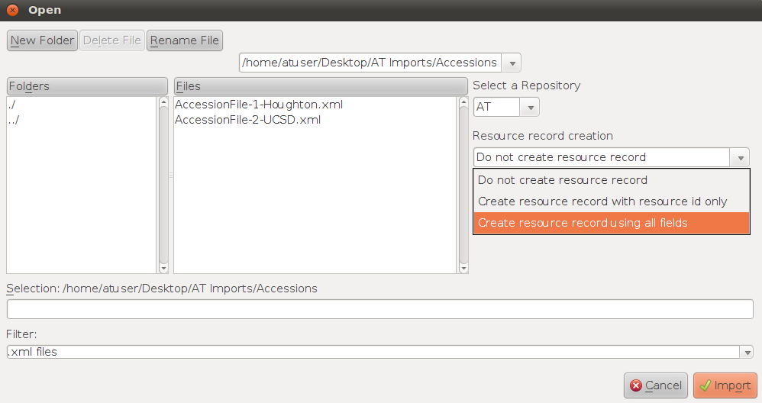

Importing EAD files:

- The legacy EAD must be 2002 DTD or Schema compliant. Earlier versions of EAD will not import.
- From the Import menu select Import EAD.
- Choose the EAD to be imported.

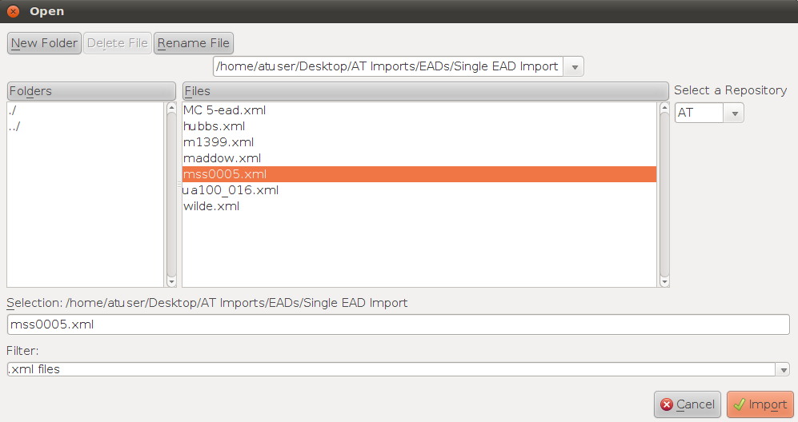

- For batch import, choose the folder that contains multiple EAD files to be imported.
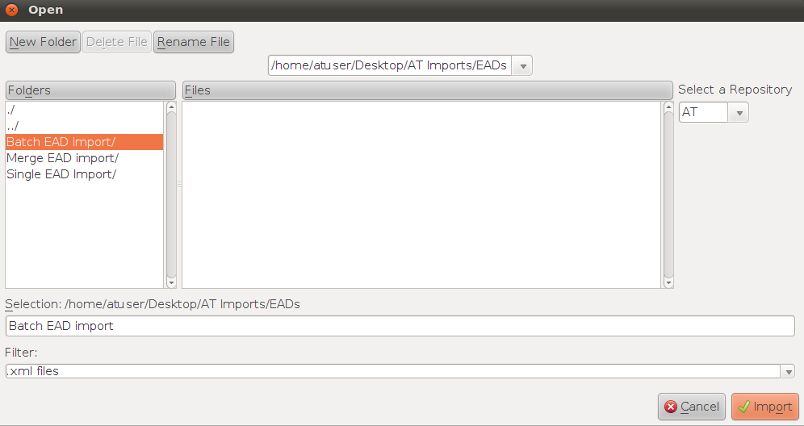

- Select the repository that holds the materials described in the finding aid.
- Click Import to begin.

Importing MARCXML records:

- The source file may contain only one MARCXML record conforming to the constraints described in Chapter 6 of the AT User Manual.
- From the Import menu select Import MARC.
- Choose the file containing the MARCXML record to import.
- Select the repository that holds the materials described in the finding aid.
- Indicate the level for the resource description.
- Indicate the resource identifier.
- Indicate whether you wish to import the entire MARCXML record or only the 1xx, 6xx and 7xx fields for name and subject headings. If the latter, there must be a targeted resource description present for the headings to be added to.
- Click Import to begin.

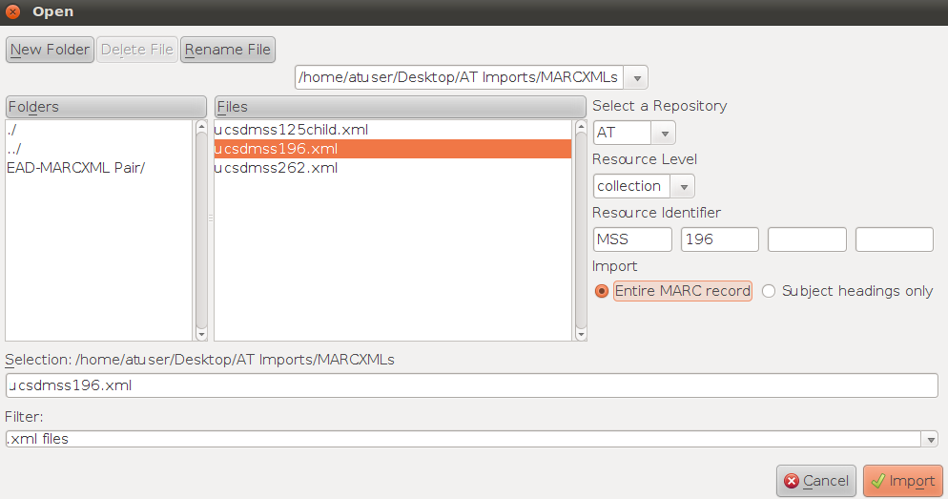

Note: MARCXML records cannot be batch imported.

Importing Controlled Access Headings from MARCXML Records:

In some cases, the detailed description of a resource may be in EAD format, but the controlled access headings are in the MARC record. It is possible to import only the controlled access headings from the MARXML record and add them to the resource description created from importing the EAD file.

- Import an EAD file.
- Import the MARCXML corresponding to the EAD and containing the controlled access headings.
- When importing the MARCXML:
  - Make sure the resource identifier matches the resource identifier of the resource record to which the controlled headings are to be assigned.
Note: by entering the wrong resource identifier it is possible to assign the controlled access headings to the wrong resource description. In that event, the headings will need to be manually unlinked from the resource description. Also, if there is no resource in the database matching the resource identifier, the import of the controlled access headings will fail.
  - Select the option for "Subject headings only"
- Select Import

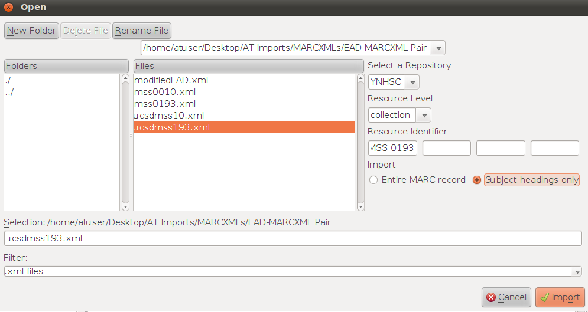

Import Logs:
Every import event concludes with the display of an import log. The import log indicates:
- What was attempted to be imported.
- What was successfully imported.
- What was unsuccessfully imported.
- The duration for the import.
- Any problems with the imported data that should be fixed in the AT database.
- Any terms added to lookup lists.

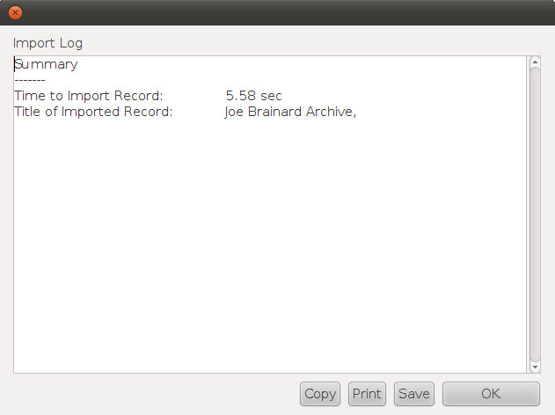

The import log can be printed or saved as an encoded text file that is easily opened with a word processing program.
Exercise 10: Importing legacy data

From the AT Imports folder on the desktop of the AT vm:

- Import the accession files located in the Accessions folder (some are tab delimited files, *.txt, while other are *.xml files)

- Import one at a time the EADs (m1399, maddow, mss0005) located in the Single EAD Import folder

- Import the EADs located in the Batch EAD import folder

- Import the MARCXML record located in the MARCXMLs folder

- Import the controlled headings from the MARCXML records located in the same folder and add them to the appropriate resource records (MSS 0010 and MSS 0193)

XIII. Data cleanup

For a number of reasons—imperfect source data, data incompatibilities between source data format and AT data format, limitations of the AT database backend, and inconsistent data entry—legacy data imported into the AT will require some form of cleanup. Data cleanup can be lessened to some extent by making sure that the source data is in as good an order as possible before importing it. The maxim "garbage in, garbage out" applies here, unless of course the garbage is significant enough to prevent import of the data at all.

As already noted above, the import logs generated after each import event serve to point out problems with the imported data that may need to be fixed. While the import logs serve as good guideposts, they report only the most obvious and frequently encountered problems. Thus, as a basic data management rule, it is prudent to investigate all data imported into the AT to assure that it has been imported as expected and that it will behave in the AT environment as it is supposed to. Failure to clean up legacy data, and all data for that matter, will lead to subsequent problems within the Toolkit.

Correcting invalid resource records:

Resource records that do not contain all the required validation fields may be imported into the Toolkit. These fields must be corrected before any additional information can be added and saved to the record. The missing data can create issues with merging or linking data entries and should be the first item attended to when cleaning up data.

- After a resource record or batch of resource records is imported, an Import Log will appear. Invalid files will be listed as in the example below.

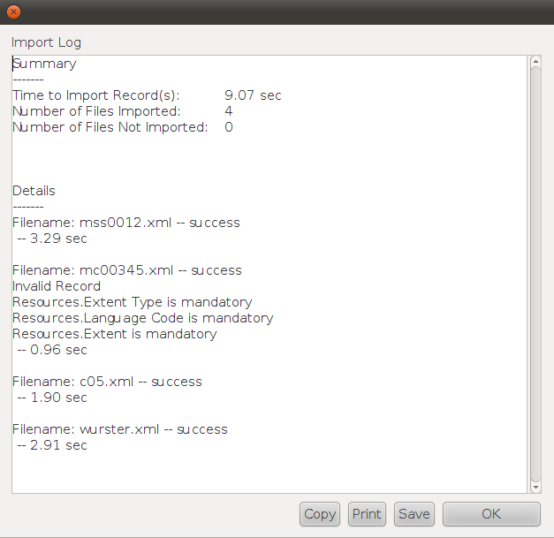

The file mc00345 is an invalid record because extent and language information required in the AT resource record was not imported from the source file.

The EAD files are all named by their Resource Identifier, and thus are easy to find after import by searching on the Resource Identifier field.

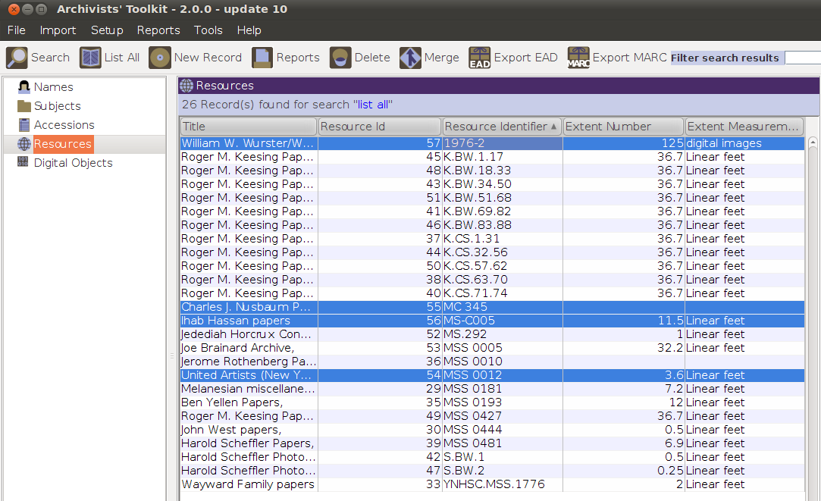

- Open each invalid record, input data into the fields necessary to make the record valid, then click Save to save the upgraded record.

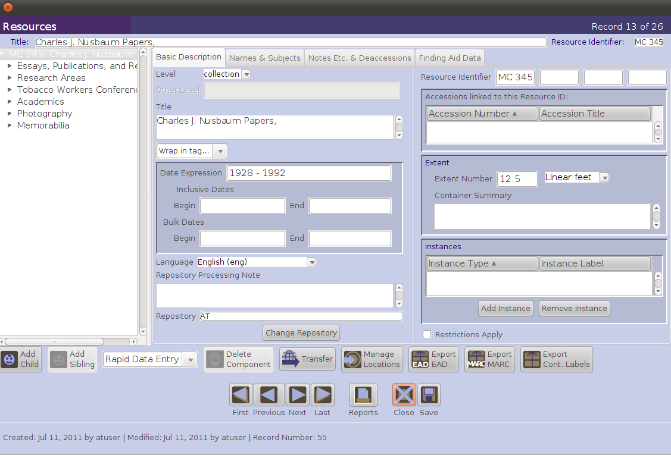
Cleaning up lookup list terms:

Incorrect, conflicting, or non-standard terms can be added to lookup lists during import. Converting these terms to preferred or standardized forms will ensure data is consistently entered and will also prevent data processing errors.

- During import, the Import Log will inform you if terms have been added to the lookup lists. In the example below, the terms "folder" and "folders" have been added to the Extent Type lookup list.

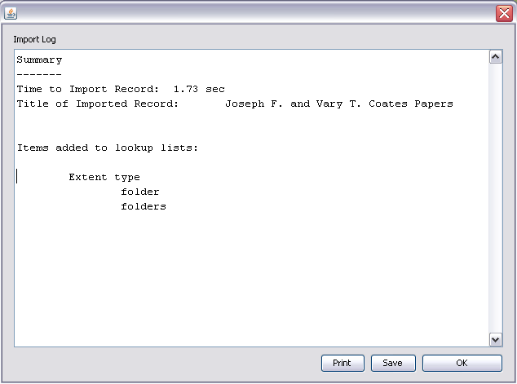

- To remove this term, select Lookup Lists from the Setup menu.
- In the Edit Lookup Lists box, select the field that requires editing. In this case it is Extent Type.

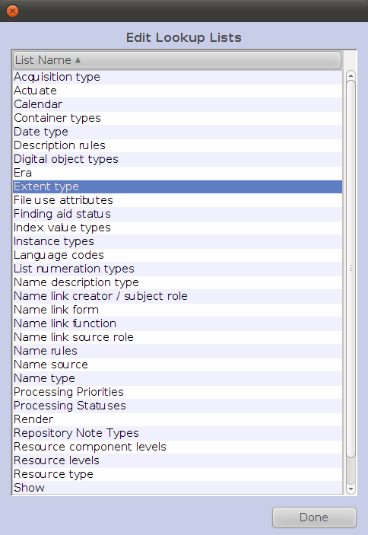

- Select the term you want to modify (i.e, remove, change, or merge).
- If merging, also select the term you want to merge the first selected term into.

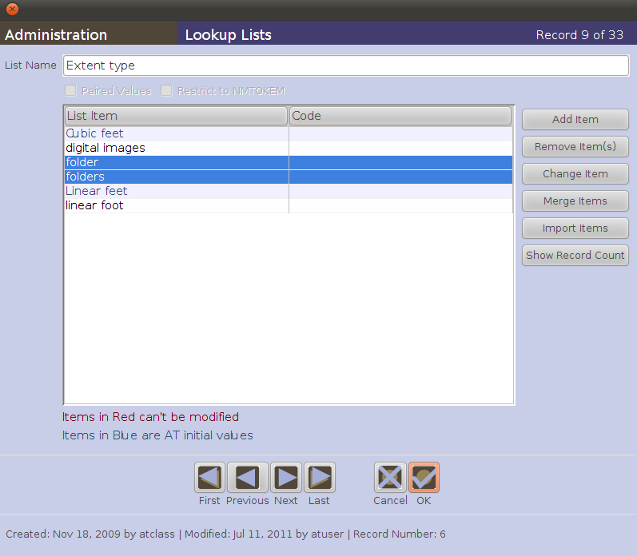

- Click on the Remove (to delete), Change (to edit the form of the term), or Merge (to convert one term in the list to another in the list) button.

A new screen will open indicating how many records are affected by the action and asking if the action is to be continued. In the case of the merge function, you will be asked to indicate what heading is to be merged into.

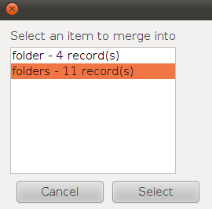

- Click on the Select button to complete the action. Again the Merge function will be followed by another dialogue box asking if you are sure. Selecting Yes will complete the Merge function.
Note: once completed the Remove, Change, Merge functions cannot be undone. These tools should be used with an understanding of their power and irreversibility.

Correcting Names and Subjects variants:

Name and subject variants can enter into the Toolkit through import (as well as through data entry error). Merging two terms together results in the correction of the non-preferred form(s), and in all accession and description records being linked to the preferred form.

- From the Names or Subjects list screen, select the authoritative or preferred form of a heading and the variant form that is to be converted to the preferred form.

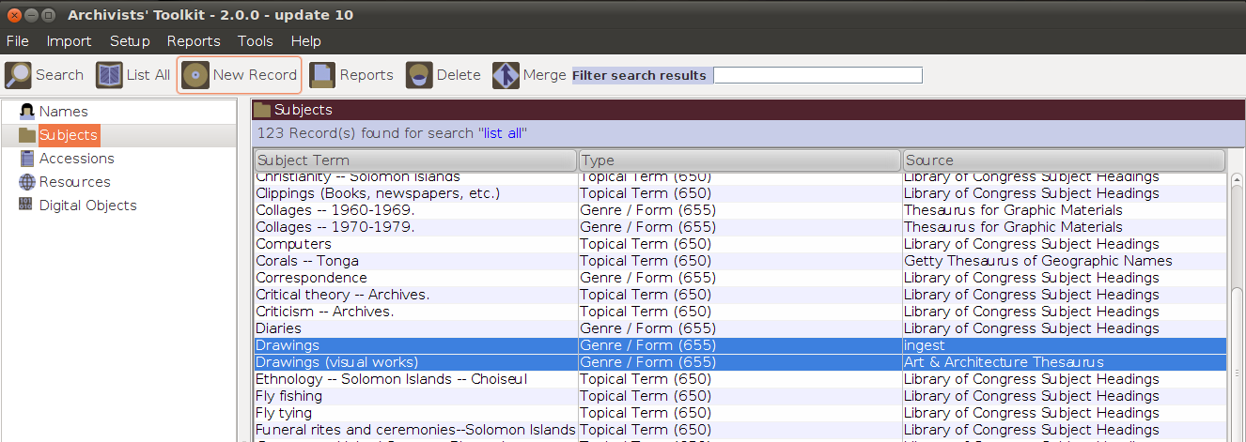

- Click on the Merge button, located at the top of the screen.
- Indicate the term to be merged into or converted to.

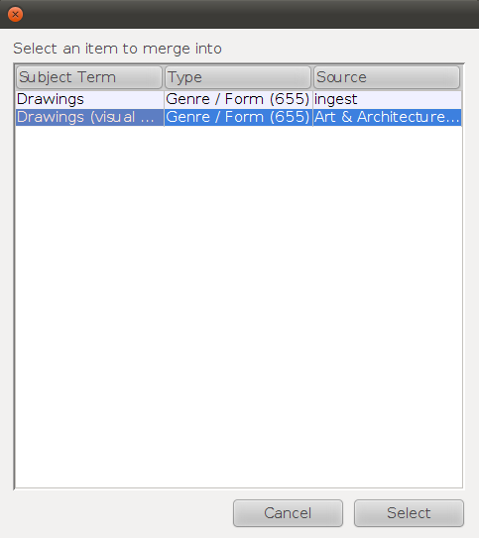

- A message will appear, informing you of the number of records that will be updated. Select Yes, and the items will be merged.

All of the records linked to the variant term will now be linked to the authorized term.

Names terms can be modified in exactly the same way through the Names functional area.

As with modifying Lookup lists, the Merge function, once completed, cannot be undone.
Exercise 11: Data cleanup

- Using the Import Logs saved from Exercise 11, the Import exercise, identify and correct as many of the data problems as you can.

- Keep a list of what you did for comparison with the work of others in the workshop.

XIV. Generating reports

There are more than 35 different types of default reports available in the AT application. Most reports are only accessible through a particular functional area; for example, subject reports are available through the Subjects functional area.

The AT allows you to print an individual screen or record, to generate a report containing data from all records of a type (e.g., all accession records), or to produce a report that draws upon data in only a subset of records within a particular functional area. When generating reports for multiple records, the output reflects the order of the result set displayed in the list screen for a specific functional area.

The vast majority of reports can be saved in different file formats. Which file format you choose depends on your intended application of the data. File format options include the following: PDF, HTML, RTF, Excel, or CSV. Currently the PDF, RTF, and HTML options produce the most ready-to-use reports. The RTF option is useful for bringing the report information into MS Word for editing. The Excel format is helpful for manipulating the report in a spreadsheet format. For tabular reports, such as Print Screen, the CSV option is useful to extract delimited data.

You may also print or preview each report, with the exception of the two versions of the finding aid report. To preview a file, the Select Output field must be set to "Printer."

See Chapter 14 of the AT User Manual for more detailed information about the variety of reports and how to create them, and see Chapter 15 for how to customize reports.

Repository Profile:

A Repository Profile provides a quick snapshot of the repository’s holdings listed in the Toolkit. Statistical information about Resources, Accessions, Extent of Holdings, Name Authorities and Subject Authorities is compiled within the report.

To generate a repository profile:

- From the Reports menu, select Generate Repository Profile.

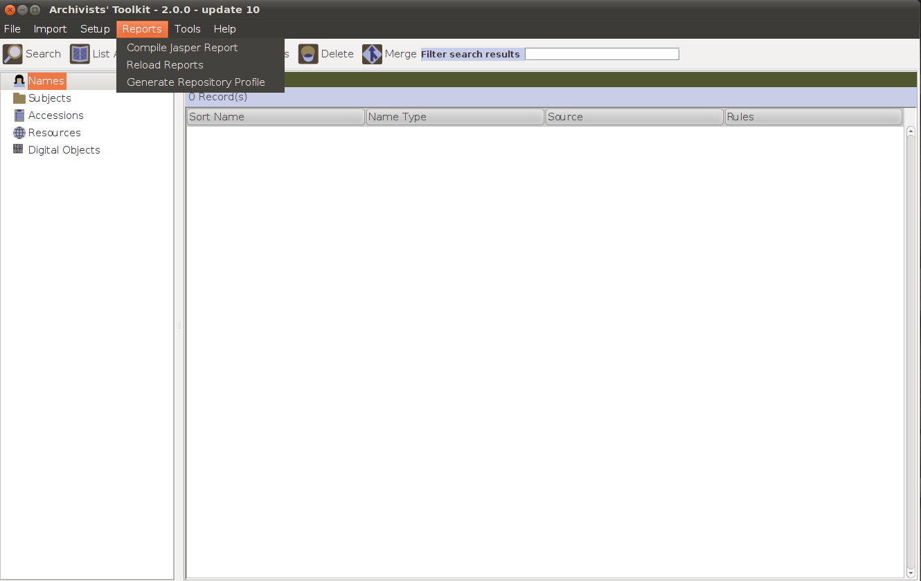
1
- The Toolkit presents a progress graphic as the report is generating. Upon completion, a JasperViewer window will appear with a preview of the Comprehensive Repository Profile report. This preview can then be printed or saved.

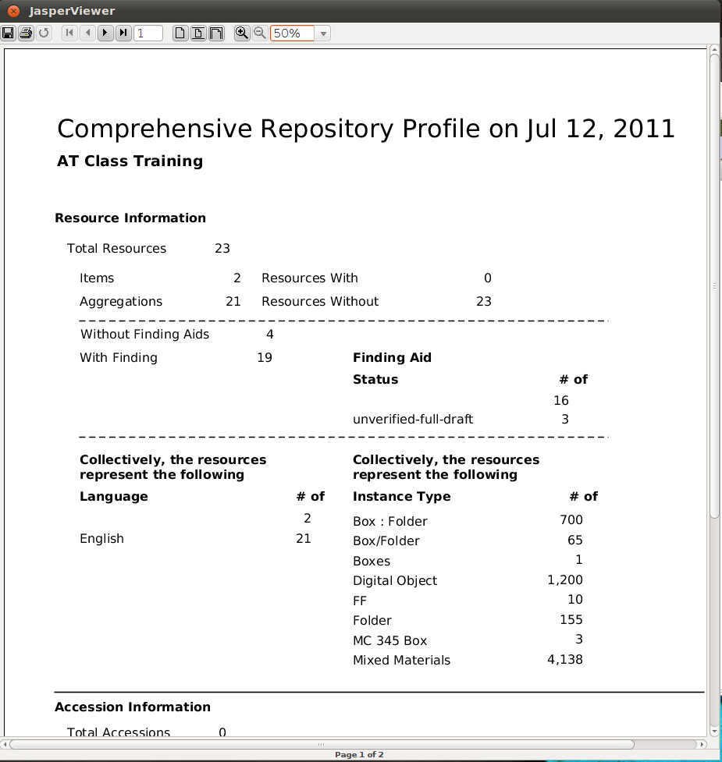
2
Locations:

The Location Shelf List report displays a list of locations and indicates which accessions or resources are assigned to those locations.

To generate a Locations Shelf List:
- Select Locations from the Tools Menu.
- Click on the Reports button.
- Select the report Output and choose Save, Preview or Print.

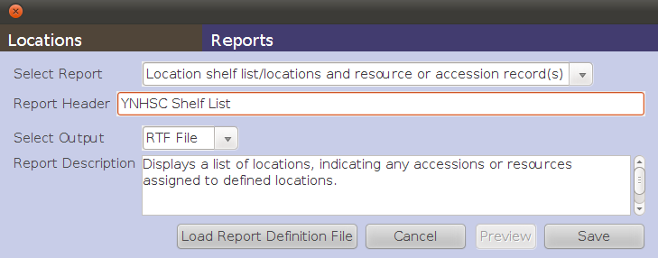
Generating reports for the functional areas:

Reports can be generated from list screens or from individual records. Using the Reports button from the list screen allows for the creation of reports for a group of records, while generating reports from an individual record produces a report for only that single record. A report showing how many accessions were processed in the last fiscal year would be generated from the accessions list, while a report serving as a report for an accession would be generated from the single accession record.

Generating a report for a single record:

- From within any record press the Reports button.
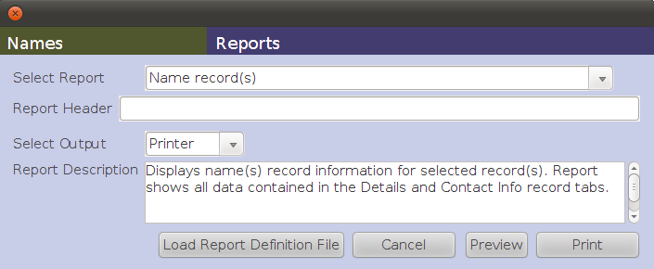
- Select the type of report desired from the pull-down menu. For example, to print a name record, select Name Record(s).
- Enter any text you wish to appear in the Report Header.
- Select Output for the report. Options are: Printer, PDF, HTML, RTF, Excel, or CSV.
- Press the Print, Preview, or Save button depending on the desired output. Remember that Printer must be selected as Output in order to be able to use the Preview button.

Generating a report for multiple records:

Any report can be generated for a record set of more than one record. To print a formatted report containing data from multiple records, you must first create the list of records to be output into the report. You can do this by using the List All button to generate a report of all records of a given type. Or, you can generate a report for multiple records by using the filter or search options to create a subset of records.

Generating a record set:

- From any list screen, use the List All button and filter or search options or select the desired records with the Shift/Ctrl keys, then use the right-click mouse function and highlight the list selected records option to create the set of records you wish to output.
- Click on the column headings to sort the records in the order you wish them to be listed in the report.
- Press the Reports button.
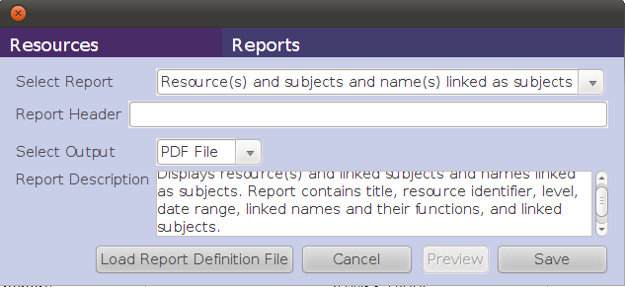

- The Select Report field provides a list of reports available for the functional area.
- Enter any text you wish to appear in the Report Header.
- Select Output for the report. Options are: Printer, PDF, HTML, RTF, Excel, or CSV.
- Press the Print, Preview, or Save button.
Exercise 12: Creating standard reports

- For the YNHSC AT database:
  - Generate a list of names related to accessions, resources, and digital objects
  - Generate a shelf list

XV. Exporting EAD, MARCXML, and print finding aids

The AT enables the production of several exports. Exports are XML or HTML documents produced according to community standards and are usable in information systems such as ILS or EAD databases. All the exports produced by the AT are intended to foster access to the described materials.

EAD files are XML-encoded documents compliant with the EAD 2002 schema. These may be uploaded to an EAD database for indexing and made publicly searchable with EAD files from the same repository and/or other repositories.

- Multi-level description of a resource
- Can include references to Digital Objects
- Can be batch exported
- Export options:
  - Numbered <c01> or unnumbered <c> components.
  - Suppression of components and notes marked Internal Only
  - Inclusion of Digital Objects as <dao> elements
  - Use Digital Object ID as HREF

Exporting EAD files:

- Open or select in the resource list the resource description(s) to be exported.
- Press the Export EAD button.

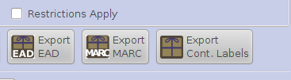
2

- Indicate if you wish to output numbered component levels (<c01> as opposed to <c>).
- Indicate if you wish to suppress components and notes when the status is set to "Internal." If checked, the notes marked “internal” will not be exported. If left unchecked, the notes marked “internal” will be exported with the EAD audience attribute set to "internal."
- Indicate if you wish to include <dao> elements in the output. This is only relevant when there are digital object records linked to the description. If left unchecked, the EAD will not include any <dao> elements. If selected, the <dao> will reference the METS identifier where there is one. Where there is no METS identifier, the <dao> will reference the file versions and their file use statements, and output the file versions listed according to their sequence.
- Indicate file name (usually the same as the EAD Identifier) and targeted location for the export.
- Press Save to export EAD.

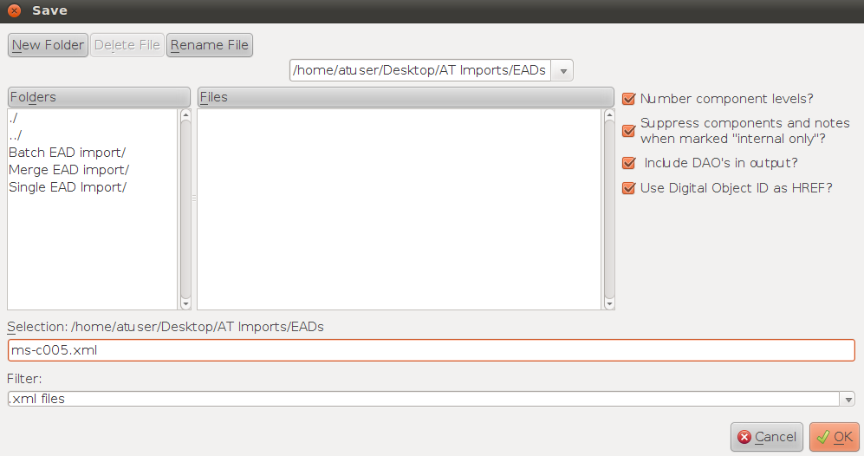
6
3
4
5
7

- A progress graphic will appear while the EAD is generating.
- An Import/Export Log will appear at the completion of the process, indicating the export time and output file(s).
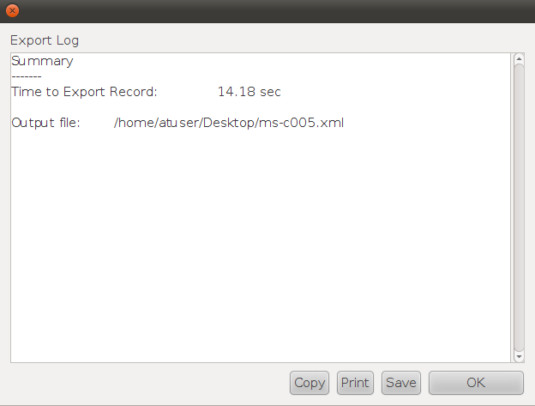
9

MARCXML files are XML-encoded documents compliant with the MARCXML schema. These may be uploaded to an ILS to be searched amongst other MARC records.

- Parent level record
- Does not indicate hierarchical or structural relationships
- Includes references to Digital Objects at parent level
- Can be batch exported
- Export options:
  - Suppression of components and notes marked Internal Only

Exporting MARC XML files:

- Open the resource description or select in the resource list one or more resources to be exported.
- Press the Export MARC button.

- Indicate if you wish to suppress components and notes when the status is set to "Internal." If selected, the internal notes will not be exported. If unselected, the internal notes will be exported.
- Indicate file name and targeted location for the export.
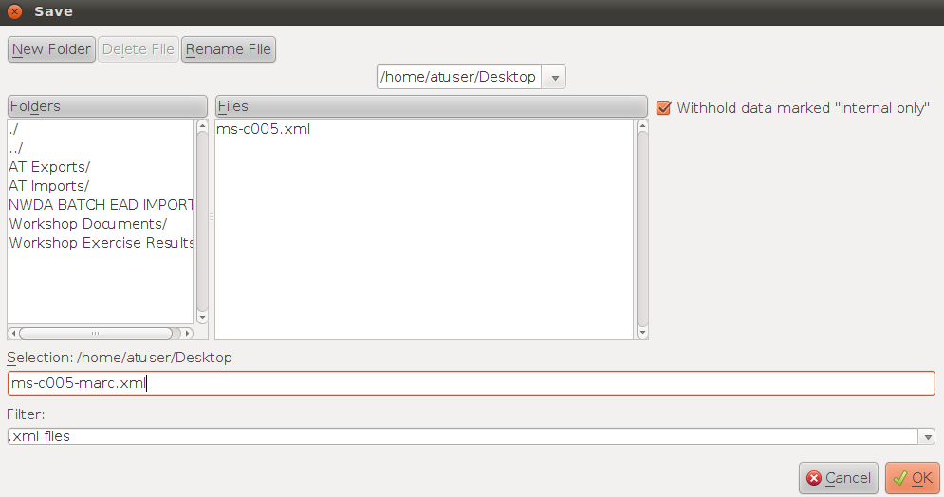

- Press Save to export MARCXML.
- A progress graphic will appear while the MARCXML is generating. An Export Log will appear at the completion of the process, indicating the export time and output file(s).
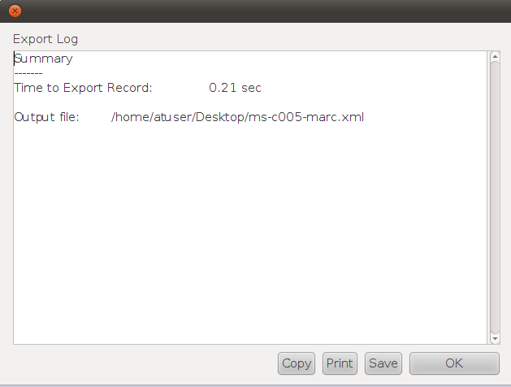

Batch Exporting EAD and MARCXML files:

- Both EAD and MARCXML records can be batch exported.
- Select in the resource list the resources for which you want to batch export records. It can be the whole list, a contiguous subset, or a noncontiguous subset of the whole list.
- Chose either to export the selected resources as EAD or MARCXML

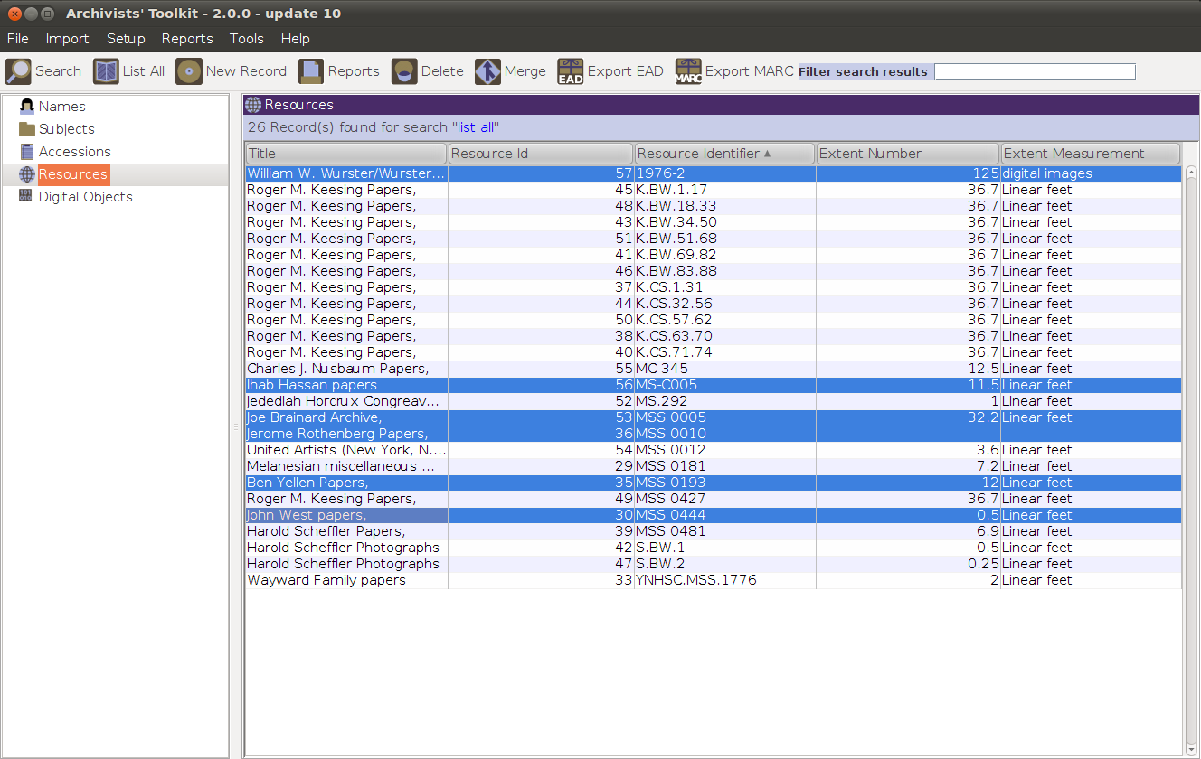
2
3

- Complete the EAD or MARCXML export form per the instructions above.
- Indicate file name and targeted location for the batch export.
- Click on Save to start the batch export process.

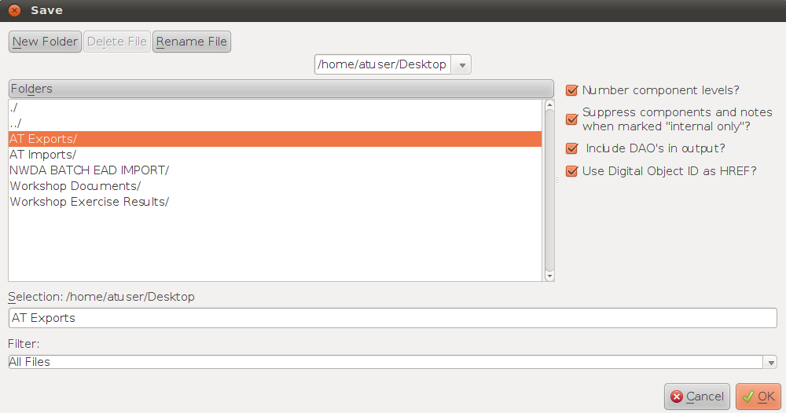
6
5

- A log report will be produced describing the results of the batch export.

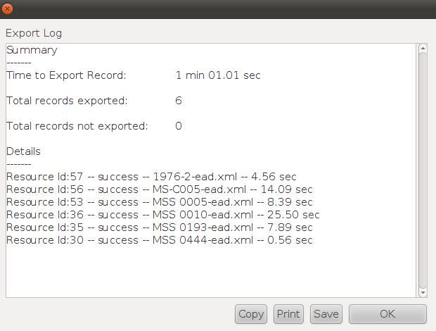

Producing a Print Finding Aid:
- Select the resource record(s) from which you wish to generate a finding aid(s).
- Click on the Reports button.
- Select Finding Aid in the Select Report drop-down list. Two options appear:
  - Suppress components and notes when marked "internal only"? Indicate if you wish to suppress components and notes when the status is set to "Internal." If checked, the internal notes will not be exported. If left unchecked, the internal notes will be included in the finding aid.
  - Include DAO’s in output? Indicate if you wish to include <dao> elements in your output. This is only relevant when there are digital object records linked to the description. If not selected, the Finding Aid will not include any <dao> elements. If selected, the <dao> will reference the METS identifier where there is one. Where there is no METS identifier, the <dao> will reference the file versions and their file use statements, and output the file versions listed according to their sequence.

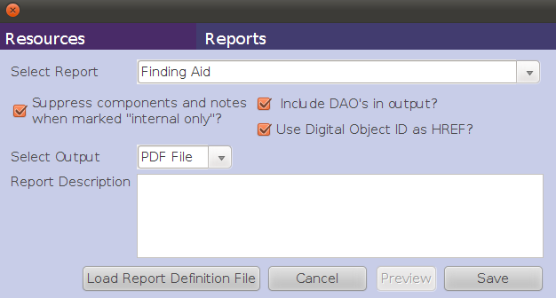
3a
3b
4
5

- Select either PDF or HTML output for the finding aid.
- Click on Save to produce the PDF or HTML output. The Preview functionality is not available for finding aids.
- Indicate the directory where the output is to be saved and the name of the file.
- Press Save.

Note: The Report Description option is not available for the printed finding aid, since most of that information is recorded on the finding aid tab of a resource record.
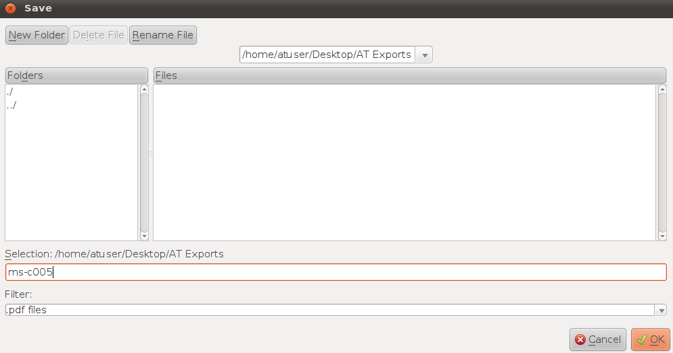
7
6

Exercise 13: Exporting Resource Descriptions

- For the Wayward family papers:
  - Export an EAD record
  - Export a MARCXML record
  - Generate PDF and HTML finding aids
XVI. Putting it all together

By now, one and a half days into this workshop, your head may be spinning. We will spend the last half of today doing a low-key exercise, hopefully with plenty of time, in which you will describe a resource completely, soup to nuts, in the AT. The instructors will be circulating to help you with any challenges encountered, so don't be shy -- let us know when questions or issues arise, or when you aren't sure what to do next. Use your workbook as a step-by-step guide to the process for Exercise 14.

Exercise 14: Final exercise

Using the Congreave document (provided as a handout and in the AT vm Workshop Documents folder), and the appropriate rules from DACS, do the following:

1. Accession description: Create an accession record for Jedediah Horcrux Congreave fly fishing materials. Try to use as many fields in the accession record as you can. The Congreave accession report is page 3 of the Congreave exercise.

2. Resource description: Use the Congreave accession record you created to “spawn” a Congreave resource record. Then use the Congreave collection description to complete the resource description. In completing the description, be sure to account for all aspects of the collection description, including name and subject headings. Also include information describing the finding aid itself.

3. When you have completed the resource description, produce the following:
  - EAD.xml
  - HTML version of finding aid report
  - PDF version of finding aid report

Appendix A:
Getting Started with the Archivists’ Toolkit

Understanding the Toolkit Architecture
The Archivists’ Toolkit requires both a client and database to function. The client is installed on your work computer; the database can be installed on either a networked server or locally on your work computer. The client provides the interface that you interact with, and the database stores the data you enter.
Client
Database

System Requirements

Minimum System Requirements for the AT Client

PC:
- Operating System: Windows 2000
- Java 5 JRE or JDK
- CPU: Pentium 3, 500Mhz
- System Memory (RAM): 128MB
- Hard Disk: 100MB free space
- Screen: 1024x768

Mac:
- Operating System: Mac OS X 10.4.5
- Java 5 JRE or JDK
- CPU: G3 500Mhz
- System Memory (RAM): 256MB
- Hard Disk: 100MB free space
- Screen: 1024x768

Supported Database Back Ends

- MySQL 5.0 (with the InnoDB storage engine)
- MS SQL Server 2005 (or higher)
- Oracle 10g
Using the AT Sandbox

The Toolkit team has set up a sandbox in which beginning users can test out the
Toolkit’s functionality without installing a backend database. To use the Sandbox:

- Download the most recent version of the AT client (http://www.archiviststoolkit.org/downloads/index.shtml)
- Run the installer
- Launch the application
- Type in the appropriate connection information available here:
http://archiviststoolkit.org/support/sandbox2.0

Remember that any data that you input into the sandbox environment will be accessible and editable by anyone using the sandbox environment. This is a place for you to test AT functionality only, not a place to store your data long term.

Setting the AT Up in a Production Environment

Before setting up the Toolkit in a production environment, it helps to ask the following questions:

What type of database back end do I want to use?
Your institution may have contracts with particular software companies, or have expertise in one type of database backend over another. It can be tricky to move from one database type to another so it’s important to start with the one you plan to use for the long term.

Where will the database be stored?
Do you want a networked installation, where the database is stored on a server and many clients can access it, or is a local instance suitable for your needs?

Who will be in charge of managing the database? Who will be considered a Superuser of the application?
Determining roles and responsibilities of different types of AT users (see Chapter 5 of the Archivists' Toolkit Version 1.5/1.5.9: User Manual at http://archiviststoolkit.org/sites/default/files/AT1_5_UserManual.pdf, pages 45-60) is extremely important. It is essential to ask who is responsible for ensuring the database is backed up on a regular basis.

What type of legacy data do I have, and how will I import it?
Chapter 6 of the User Manual details the types of data imports available.

How will the AT fit into my repository's current workflows?
If you have processing guidelines, how does the AT fit in with them?

For More Information

Installation:
Check the Installation Guidelines.
http://archiviststoolkit.org/support/MaintenanceProgram

Using the Application:
The User Manual covers all the functionality of the AT, from basic data entry to customization.
http://archiviststoolkit.org/sites/default/files/AT1_5_UserManual.pdf

Glossary of AT terms:
This glossary defines terms that are useful for understanding the features, interface, and documentation for the AT.
http://archiviststoolkit.org/sites/default/files/AT1_5_UserManual.pdf (pages 343-352)

On the AT Project:
The Overview provided on the website details the history of the project, as well as objectives for Phase 2.
http://archiviststoolkit.org/overview/phase2

Additional Questions?
Check the FAQs...
http://archiviststoolkit.org/faq
and Forums.
http://archiviststoolkit.org/forum

2.5.3: record numerical quantity associated with expressions of extent in Arabic numerals; 2.5.4: record quantity in terms of physical extent in linear or cubic feet, etc., with a footnote recommending spelling out terms rather than using abbreviations that may not be well understood by all users. See page 30 in DACS.
See http://www.oclc.org/bibformats/en/fixedfield/ctrl.shtm .
See http://www.icacds.org.uk/eng/ISAD(G).pdf .
Metadata Object Description Schema (MODS), see http://www.loc.gov/standards/mods/ .
Dublin Core Metadata Initiative (DC), see http://dublincore.org/ .
Metadata Encoding and Transmission Standard (METS), see http://www.loc.gov/standards/mets/ .
For a complete description of AT records and basic of ways of working with them, see Chapter 3 of the Archivists' Toolkit Version 1.5/1.5.9 User Manual, which is available online at http://archiviststoolkit.org/sites/default/files/AT1_5_UserManual.pdf (pages 19-32).
Chapter 15 of the Archivists' Toolkit Version 1.5/1.5.9 User Manual is available online at http://archiviststoolkit.org/sites/default/files/AT1_5_UserManual.pdf (pages 230-278).
An explanation of these terms and how to apply them to the resources you are describing is provided in Chapter 9 of the Archivists' Toolkit Version 1.5/1.5.9 User Manual, available online at http://archiviststoolkit.org/sites/default/files/AT1_5_UserManual.pdf (pages 101-154). The default list of terms in the AT is based on descriptors for bibliographic formats. With the exception of the terms "digital object” and “digital object link," however, all the terms in the list may be modified or replaced according to the needs of the repository.
In the default RDE tool, the values entered for Level, Note type and Note value, Instance Type, and Container Types will carry forward to the next component record when OK+1 is selected. These are called sticky values.
Additional information about this resource is available online at http://authorities.loc.gov/ .
Additional information about this resource is available online at http://www.getty.edu/research/tools/vocabularies/aat/index.html .
Additional information about this resource is available online at http://www.loc.gov/marc/sourcelist/ .
Additional information about the International Standard Archival Authority Record for Corporate Bodies, Persons, and Families is available at http://www.icacds.org.uk/eng/isaar2ndedn-e_3_1.pdf .
Additional information about this resource is available online at http://authorities.loc.gov/ .
Name Authority Cooperative Program. Additional information is available online at http://www.loc.gov/catdir/pcc/naco/ .
Additional information about this ISAAR(CPF)- and EAC-based resource is available online at http://nad.ra.se/static/back_eng.html .
Additional information about this resource is available online at http://www.getty.edu/research/tools/vocabularies/ulan/index.html .
Additional information about this resource is available online at http://www.aacr2.org/ .
Chapters 14-15 of the Archivists' Toolkit Version 1.5/1.5.9 User Manual are available online at http://archiviststoolkit.org/sites/default/files/AT1_5_UserManual.pdf (pages 214-278).
For additional information see http://www.loc.gov/ead/eadschema.html .
For additional information see http://www.loc.gov/standards/marcxml/ .

